TEMPERATURE AND HEAT

Remember to photocopy 4 pages onto one sheet by going A3→A4 AND back to back on the photocopier

Student name: ________________________________

This booklet contains every higher and ordinary level question that has appeared on an exam paper on this topic from 2002–2023
Worked solutions to Ordinary Level Maths questions can be found at the end of the booklet.
Fully worked solutions to all higher level past papers can be found on the homepage of thephysicsteacher.ie

Screencasts of all topics plus a wide range of other resources via this link

You can find this document plus all other booklets on the homepage of thephysicsteacher.ie
Last updated: 04/08/2024
Noel Cunningham
Contents
The science of learning quiz: Part 15 3
1: TEMPERATURE AND THERMOMETERS 5
Something to think about 5
Student Notes 5
Temperature 5
The kelvin scale 6
Relationship between degrees celsius and kelvin 6
Thermometric properties 7
Disagreement between thermometers 7
TO CALIBRATE A THERMOCOUPLE 8
Background reading 13
SLOP 14
The science of learning quiz: Part 16 15
2: QUANTITY OF HEAT AND HEAT TRANSFER 17
Something to think about 17
Student Notes 19
Heat transfer 19
1. Convection 19
2. Radiation 19
3. Conduction 20
U-Values 20
Heat capacity 21
Storage heaters 21
Specific heat capacity 22
Specific heat capacity – maths questions 23
Latent heat 26
Latent heat – maths questions 28
The heat pump 31
Evolution, sweat and latent heat 32
SLOP 50
TEMPERATURE AND HEAT EXAM QUESTIONS 2002 – 2022 52
Temperature: Ordinary level questions 53
Temperature: Higher level questions 54
Heat: Ordinary level theory questions 56
Heat: Ordinary level questions involving specific heat capacity 59
Heat: Higher level questions including specific heat capacity 61
Heat: Ordinary level questions including specific heat capacity and latent heat 63
Heat: Higher level questions including specific heat capacity and latent heat 64
SOLUTIONS TO ORDINARY LEVEL MATHS QUESTIONS 2002 - 2022 67

“A great many people think they are thinking when they are merely rearranging their prejudices.”
William James

"Go, go, go, said the bird: human kind
Cannot bear very much reality.
TS Elliot

The science of learning quiz: Part 15

- What is meant by the word ‘meta-cognition’?

- What is meant by the term ‘interleaved practice’ and why is it so effective as a study technique?

- Describe the difference between a fixed and a growth mindset and explain the significance this has for a student.

Answers

- What is meant by the word ‘meta-cognition’?
Meta-cognition is the name given to the study of how we learn.
Being metacognitive can be likened to being more conscious, reflective, and aware of our progress along the learning path. One example of this is as follows: medical researchers were fascinated with how veteran cab drivers could navigate the busy streets of London so effortlessly and remember all the shortcuts without consulting a map so they did brain scans and discovered that the cabbies' hippocampal areas, the part of the brain associated with spatial reasoning, were larger than those of other adults. All those years of driving and remembering routes had literally changed their brains. So if you want to know why you have to spend so much time practicing any new skill, there’s your answer.

Amateurs are content at some point to let their efforts become bottom-up operations. After about fifty hours of training — whether in skiing or driving — people get to that “good-enough” performance level, where they can go through the motions more or less effortlessly. They no longer feel the need for concentrated practice, but are content to coast on what they’ve learned. No matter how much more they practice in this bottom-up mode, their improvement will be negligible.
The experts, in contrast, keep paying attention top-down, intentionally counteracting the brain’s urge to automatize routines. They concentrate actively on those moves they have yet to perfect, on correcting what’s not working in their game, and on refining their mental models of how to play the game, or focusing on the particulars of feedback from a seasoned coach. Those at the top never stop learning: if at any point they start coasting and stop such smart practice, too much of their game becomes bottom-up and their skills plateau.
Focus: The Hidden Driver of Excellence, celebrated psychologist and journalist Daniel Goleman,

- What is meant by the term ‘interleaved practice’ and why is it so effective as a study technique?
If you have three subjects to study tonight (say Physics, Chemistry, Biology), it’s much more effective to ‘interleave’ them. So rather than one hour of Physics followed by one hour of Chemistry followed by one hour of Biology, it’s better to do a half-hour of each, then when you’re finished one cycle go back and do another half hour of each.
Does this sound like it’s a pain in the ass? Yes.
Does it make the learning occur more slowly to begin with? Yes
Does it mean you finish a particular session feeling less confident that if you engage in ‘block learning’ (sticking with one subject until you’ve finished)? Yes
Is this reason enough to dismiss it? No. No. No
Why is interleaved practice effective?
Each time you re-visit the subject, it will/should result in the full or partial retrieval of information from the previous session(s). And retrieval is a key part of the process of information becoming securely stored in long term memory.

- Describe the difference between a fixed and a growth mindset and explain the significance this has for a student.
People with a fixed mindset tend to believe that intelligence, personality and character are all carved in stone; potential is determined at birth.
People (including students and teachers) who have a growth mindset tend to believe that intelligence, personality and character can be developed.
Those with a fixed mindset tend to allow failure (or success) to dictate who they are, while those with a growth mindset tend to see setbacks as opportunities to grow and improve themselves. These people fully appreciate that to reach their potential takes practice and perseverance.
We have a choice as to which view we adopt for ourselves and it’s never too late to change views.

1: TEMPERATURE AND THERMOMETERS

Something to think about
- Alcohol boils at about 78 ⁰C. So how can it be used in a 0⁰ C to 100 ⁰C thermometer?

- Everybody knows that body temperature is 37.6⁰ C. But why is it 37.6?

- Look at the diagrams below. Which contains the most amount of energy?

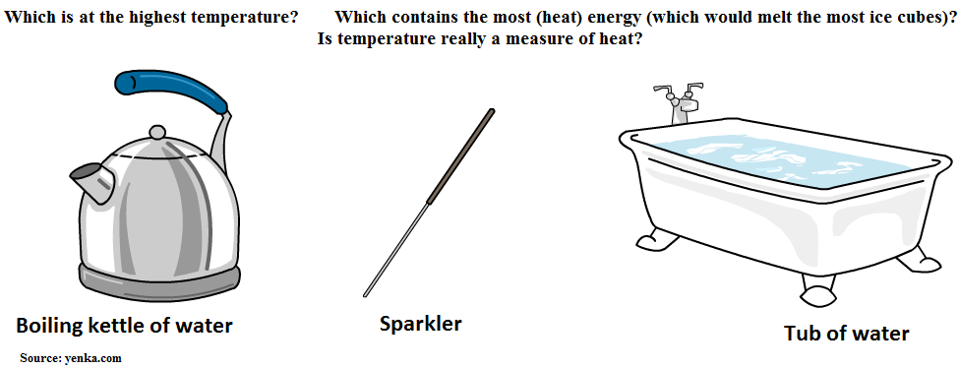

Student Notes

Temperature
The temperature of an object is a measure of the hotness of that object.
‘Hotness’ in turn is a reflection of the kinetic energy of the molecules of the material.
Note: You must use the term ‘hotness’.

A useful way to think of a thermometer does is as follows: "A thermometer is a molecular speedometer"
Heat is a form of energy

2019 Question 8 [Ordinary Level]
A student measured the temperature of a large bath full of water and a small cup full of water and said “they are both at the same temperature, so they must contain the same amount of energy”.
Is the student’s statement correct? Explain your answer.
Solution
No. The water in the bath contains much more energy because there is a much greater mass of water in the bath than in the cup.

The Kelvin scale

The Celsius scale is fine for measuring temperature but having ‘negative’ temperatures is a bit odd. Temperature measures ‘hotness’ (and you can’t have a negative hotness so it makes more sense to have a different scale which starts at zero (corresponding to molecules being motionless) and working up from there. Ladies and gentlemen, I present to you the kelvin scale.

For the kelvin scale we take our lowest possible temperature to be 0 kelvin (known as ‘absolute zero’) and consider a difference in temperature of 1 K to be equivalent to a difference in temperature of 1 ⁰C.

The SI unit of temperature is the kelvin (K)

Absolute zero (on the kelvin scale) corresponds to – 273.15 ⁰C

Relationship between degrees celsius and kelvin

Temperature in degrees celsius (⁰C) = (Temperature in kelvin) – 273.15

Another way of looking at it is to remember that the temperature in kelvin will always be 273.15 greater than the temperature in degrees celsius.
Note that in exam questions you have to use 273.15, not just 273.

2016 Question 5 [Higher level]  What is the value of 1.92 K in degrees Celsius (°C)? | Temp in °C = temp in kelvin - 273.15  = 1.92 - 273.15  = – 271.23 °C
2010 Question 5 [Ordinary level]  If the temperature of an object is 28 ⁰C, what is its temperature in Kelvin? | 273.15 + 28 = 301.15 K
2003 Question 5 [Ordinary level]  The temperature of a body is 300 K.  What is its temperature in degrees Celsius? | 300 – 273.15 = 26.85 ⁰C.

Thermometric properties

A thermometric property is any physical property that changes measurably with a change in hotness.
Note: You must use the term ‘measurably’.

Examples of thermometric properties
- Length of a column of liquid, e.g. mercury and alcohol thermometers
- Electrical resistance
- Colour (colour ‘strips’ are sometimes used by nurses and placed against a person’s forehead)
- Emf of a thermocouple (emf is a fancy word word for ‘voltage’)

Disagreement between thermometers

Two different types of thermometer may have different temperature readings at the same level of hotness.
This is an answer to the common exam question: Why do we need to have a standard thermometer?

The problem arises because different thermometric properties do not change proportionally with change in hotness.
This means we need to agree on one particular thermometer to have as a standard.
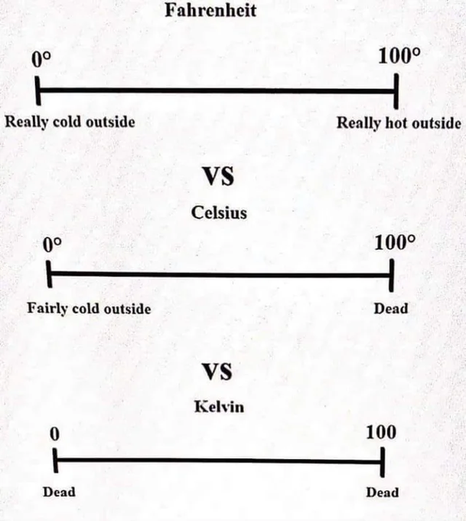

TO CALIBRATE A THERMOCOUPLE

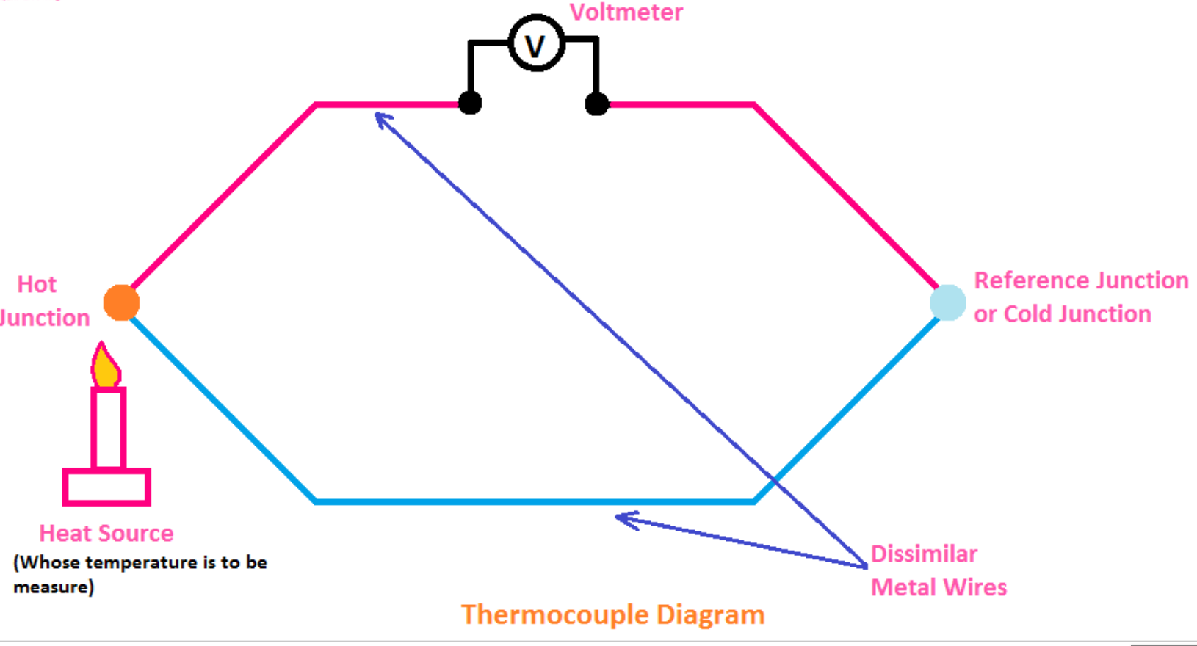 | 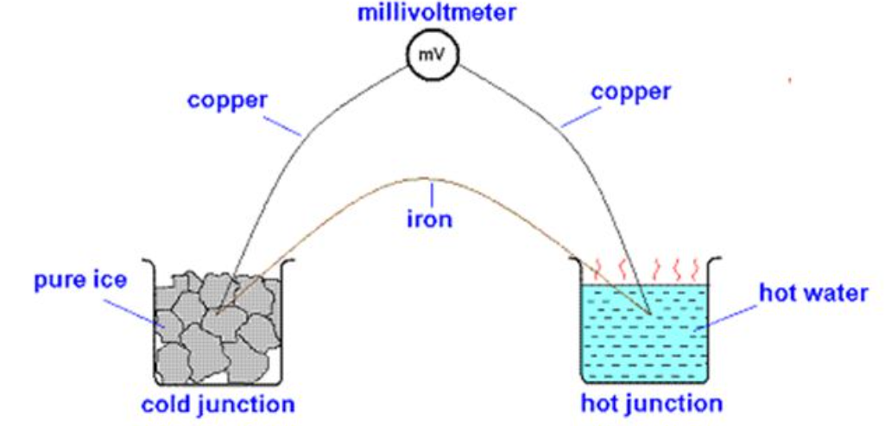

A thermocouple is comprised of two different metals joined together at both ends to form two junctions.
To use this set up as a thermometer we first need to have a graph such as the one on the right which we can refer to in order to calculate temperature. Creating this graph is referred to as ‘calibrating the thermometer’.

Procedure
- One junction (known as the cold or reference junction) is immersed in a liquid of known temperature like ice-water (0 ⁰C).
- The other junction (‘hot junction’) is immersed in water of known temperature (use a normal calibrated thermometer to measure the temperature of the hot water/hot junction).
- A temperature difference between both ends will induce an emf /voltage (which can be measured using the voltmeter).
- Note the temperature (using a laboratory thermometer) and voltage.
- Increase the temperature of the hot junction take a new set of readings.
- Plot a graph of voltage against temperature.
- You can now use the graph with this thermocouple to determine an unknown temperature of the liquid (note the voltage and use the graph to get the corresponding temperature).
Temperature (°C) | emf (volts)
See exam questions below.

RESULTS
See table of results

CONCLUSION (example)
We tested our results by using our calibration to work out the temperature of a sample of lukewarm water. We checked this against the actual temperature of the water (using a laboratory thermometer) and got very similar results. Which surprised us greatly.

SOURCES OF ERROR / PRECAUTIONS
- Heat the water very slowly so that it is easy to take temperature and length readings simultaneously.

- Have your eye level with the liquid column when taking temperature and length readings to avoid parallax error.
Why do we study the thermocouple when the alcohol thermometer works just fine for school purposes?
Calibration curve for a thermometer

Theory questions

Draw a labelled diagram of the apparatus used in the experiment. | 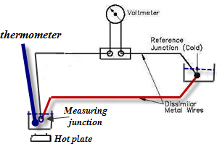
Describe the procedure you used in the experiment. | See Procedure above
Name the thermometric property of the thermometer you calibrated. | / emf / voltage
How was the value of this thermometric property measured? | voltmeter

Related exam questions
Ordinary Level: 2007, 2012

[2007 OL]
A student carried out an experiment to obtain the calibration curve of a thermometer.
The following is an extract from her report.
I placed the thermometer I was calibrating in a beaker of water along with a mercury thermometer which I used as the standard. I recorded the value of the thermometric property of my thermometer and the temperature of the water as shown on the mercury thermometer. I repeated this procedure at different temperatures. The following is the table of results that I obtained.
Temperature/°C | 0 | 20 | 40 | 60 | 80 | 100
Value of thermometric property | 4 | 12 | 24 | 40 | 64 | 150

- Draw a labelled diagram of the apparatus used in the experiment.
- Using the data in the table, draw a graph on graph paper of the value of the thermometric property against its temperature. Put temperature on the horizontal axis (X-axis).
- Use your graph to estimate the temperature when the value of the thermometric property is 50.
- Give an example of a thermometric property.
- How was the value of this thermometric property measured?

[2012 OL]
You carried out an experiment to establish the calibration curve of a thermometer.
- Describe, with the aid of a diagram, the procedure you used in the experiment.
- Name the thermometric property of the thermometer you calibrated and describe how the value of this property was measured.
- The following table shows the data obtained in an experiment to establish the calibration curve of a thermometer.
Temperature/ ⁰C | 0 | 20 | 40 | 60 | 80 | 100
Value of thermometric property | 5 | 14 | 29 | 48 | 80 | 130

Using the data in the table, draw a graph on graph paper to establish the calibration curve.
Put temperature on the horizontal axis.
- Use your calibration curve to determine the temperature when the value of the thermometric property is 60.

2011 Question 7 (c) [Higher Level]

- How would you demonstrate the principle of operation of a thermocouple?
- Describe how to establish a calibration curve for a thermocouple.

Worked solutions

[2007 OL]

[2007 OL]

2011 Question 7 (c) [Higher Level]
- How would you demonstrate the principle of operation of a thermocouple?
- One junction (reference junction) is kept cold and at a constant temperature.
- The second junction is heated.
- Note that the hotter the second junction gets, the greater the emf /voltage becomes.

- Describe how to establish a calibration curve for a thermocouple.
- Set up as shown (plus a thermometer in the hot junction).
- Hold one junction at constant cold temperature (eg 0 ºC)
- Hold the other junction in a beaker of water together with an (already calibrated) thermometer.
- Heat the water (in steps of 10 ºC approx) and note temperature and emf values each time.
- Plot a graph of emf vs. temperature. It will be a slight curve.

To use the thermocouple plus calibration curve to find the unknown temperature of a liquid
- While keeping the reference junction at the same cold temperature as before, put the other junction in the beaker containing the liquid of unknown temperature.
- Note the emf value.
- Use the calibration curve to find the temperature corresponding to the emf value.

Background reading

Origins of the Celsius and Fahrenheit scales
Everybody knows 0 degrees on the Celsius scale is the freezing point of water and 100 degrees is the boiling point. On the Fahrenheit scale, however, freezing is 32 degrees and boiling 212.
How on earth were these numbers arrived at? Do 0 and 100 degrees Fahrenheit mean anything?
Researchers have gone to their graves trying to figure out what old man Fahrenheit was up to. Here's the story as well as I can piece it together:
Daniel Gabriel Fahrenheit (1686-1736) was a German instrument maker who invented the first practical mercury thermometer. Casting about for a suitable scale for his device, he visited the Danish astronomer Ole Romer, who had devised a system of his own.
As it turned out, it was a case of the blind leading the blind.
Romer had decided that the boiling point of water should be 60 degrees. This at least had the strength of numerological tradition behind it (60 minutes in an hour, right?).
But zero was totally arbitrary, the main consideration apparently being that it should be colder than it ever got in Denmark. (Romer didn't like using negative numbers in his weather logbook.)
In addition to the boiling point of water, the landmarks on Romer's scale were the freezing point of water, 7½ degrees, and body temperature, 22 ½ degrees.
D.G., simple soul that he was, thought this cockeyed system was the soul of elegance. He made one useful change: to get rid of the fractions, he multiplied Romer's degrees by 4, giving him 30 for the freezing point and 90 for body temperature.
Then, for reasons nobody has ever been able to fathom, he multiplied all the numbers by 16/15, making 32 freezing and 96 body temperature. Boiling point for the time being he ignored altogether.
By and by Fahrenheit got ready to present his scale to London's Royal Society, the scientific big leagues of the day.
It dawned on him that it was going to look a little strange having the zero on his scale just sort of hanging off the end, so to speak. So he cooked up the explanation that zero was the temperature of a mix of ice, water, and ammonium chloride.
At some point Fahrenheit figured out that the boiling point of water came in at 212 degrees. Over time this replaced body temp as the upper landmark on his scale. Meanwhile, as more precise measurements were made, body temperature had to be adjusted to 98.6 degrees.
In short, 100 means nothing at all on the Fahrenheit scale, 96 used to mean something but doesn't anymore, and 0 is colder than it ever gets in Denmark. Brilliant.
Lest we get too down on Fahrenheit, though, consider Anders Celsius, who devised the centigrade scale (0 to 100).
Everybody agrees Celsius's scale makes more sense than Fahrenheit's. Trouble is, the original Celsius scale had 100 for freezing, 0 for boiling. In other words, it was upside-down. (The numbers were reversed after Celsius's death.)
These thermometer guys, what gets into them? Must be too much mercury exposure.
OK, you're saying, very interesting. But what I REALLY need is a temperature trivia question that will make me the life of the party.
I have just the thing. At what temperature are the Fahrenheit and Celsius readings the same? People will look at you with newfound respect when you reveal the astonishing answer: minus 40.
--CECIL ADAMS Taken from www.straightdope.com

SLOP

What is meant by temperature? | The temperature of an object is a measure of the hotness or coldness of that object.
What is the unit of temperature? | The SI unit of temperature is the Kelvin (K)
What is the difference between heat and temperature? | Heat is a form of energy; temperature is a measure of hotness.
What are the two fixed points on the Celsius scale? | The melting point and boiling point of water.
Name two scales that are used to measure temperature. | Celsius and Kelvin.
Give the equation that defines temperature on the Celsius scale. | T (⁰C) = T(K) – 273
What is the boiling point of water on the Celsius scale? | 100 °C and 373 K
The SI unit is named in honour of Lord Kelvin. What is the temperature of the boiling point of water in kelvin? | 273.15 + 100 = 373.15 K
The temperature of a body is 300 K. What is its temperature in degrees Celsius? | 300 – 273 = 27 ⁰C.
The temperature of a body is 34 °C. What is its temperature in kelvin? | 273 + 34 = 307 (K)
If the temperature of an object is 28 ⁰C, what is its temperature in Kelvin? | 273.15 + 28 = 301.15 K
Explain the term thermometric property. | A thermometric property is a property that changes measurably with temperature.
Name the thermometric property used in a mercury thermometer. | Length (or volume) of the liquid.
What is the thermometric property of a thermocouple? | emf
Name a thermometric property other than emf. | Length, pressure, volume, resistance, colour
Name one other type of thermometer and state its thermometric property. | Thermistor - resistance  Thermocouple - emf  Liquid crystal - colour
Explain why it is necessary to have a standard thermometer. | Two different types of thermometer will give slightly different readings at the same temperature

The science of learning quiz: Part 16

What is ‘learned helplessness’ and what has it got to do with Study Skills?
Learned helplessness occurs when an animal is repeatedly subjected to an aversive stimulus that it cannot escape from. Eventually the animal will stop trying to avoid the stimulus and behave as if it is utterly helpless to change the situation. Even when opportunities to escape are presented, this learned helplessness will prevent any the animal from even attempting to escape.
Consider a student who has always performed poorly in exams. A teacher comes along and suggests that the reason they are performing poorly is because their study technique is all wrong. Even when a new opportunity to improve their study pattern is presented, the student will quite often refuse to change (he has ‘learned’ over the years that he is ‘helpless’).
Some psychological disorders are also associated with learned helplessness, e.g. depression, anxiety, phobias, shyness and loneliness.
This is all to say that if you can’t get yourself out of this mindset then all the talking in the world from me will be of little if any use.
But as in all things, step one is just to acknowledge (accept) that you may be in this position.

Answers

What is ‘learned helplessness’ and what has it got to do with Study Skills?
Learned helplessness occurs when an animal (including humans) is repeatedly subjected to an aversive stimulus that it cannot escape from. Eventually the animal will stop trying to avoid the stimulus and behave as if it is utterly helpless to change the situation. Even when opportunities to escape are presented, this learned helplessness will prevent any the animal from even attempting to escape.
Consider a student who has always performed poorly in exams. A teacher comes along and suggests that the reason they are performing poorly is because their study technique is all wrong. Even when a new opportunity to improve their study pattern is presented, the student will quite often refuse to change (he has ‘learned’ over the years that he is ‘helpless’).
Some psychological disorders are also associated with learned helplessness, e.g. depression, anxiety, phobias, shyness and loneliness.
This is all to say that if you can’t get yourself out of this mindset then all the talking in the world from me will be of little if any use.
But as in all things, step one is just to acknowledge (and accept) that you may be in this position.

2: QUANTITY OF HEAT AND HEAT TRANSFER

Something to think about
- Next summer will be the coldest summer that humans will ever experience.
- Nobody cares.

- A candle needs oxygen to burn, which is why, if we want to resuscitate a dying fire, we blow on it.
So why does blowing on a candle put it out?

- If you lick a frozen pipe why will your tongue stick to the pipe?
- Everybody knows heat rises. Why does heat rise?

- Why is water a very good substance for fire extinguishers (apart from the fact that it’s cheap)?
- The foil and the cotton towel in the diagram are both at the same temperature – so why does the foil feel colder?
- How is it possible to walk across hot coals and not get hurt?
Hint: it’s not about preparing your mind in advance
- Your oven at home is at 200 ⁰C. Why is okay to put your hand in the oven but you only get burnt if you touch the metal parts.
- Why might a glass crack when you pour boiling water into it?
- Why is colder at the top of a mountain even though you are closer to the sun?
- The energy in food is often measured in calories, but energy is energy so calories and joules must be connected. It turns out that one calorie is the amount of heat needed to raise the temperature of 1,000 grams of water by one degree.
How can we convert from calories to joules?
Note that it’s not that joules are ‘good’ energy and calories are ‘bad’ energy because calories make you fat, as apparently some believe.

- Take two ice cubes. Wrap one in tin foil and leave the other one unwrapped. Which one melts first? Why?
- Why does a thermometer continue to heat up even after taking away the heat source?

Latent heat

- A dog pants to help him cool - how does this work?
- Flamingos pee down their legs to help him cool down – how does this work?
Would it work for you? Try it and see. How could you tell if it was working?

- How come you often feel colder when you come out of the water (after going for a swim) even though the air is warmer than the water?

- Why is a steam burn more dangerous than a burn from boiling water, even when both are at the same temperature (100⁰ C)?

- It’s often said that hurricanes ‘pick up’ energy when they pass over oceans. How does this happen?
- Why does water evaporate even though its temperature is well below 100 ⁰C?

- Benjamin Franklin investigated the phenomenon of evaporation. He wet a thermometer with ether, then blew on it with a bellows until ice formed. Why did this happen? You can do something similar by simply wrapping a cloth around a thermometer and dipping it in alcohol.
Or simply place a dollop of perfume on your hand - what should you notice (apart from the smell) and why?

- The famous cyclist Eddie Mercx could regularly cycle for eight hours in very hot conditions in a road race, but he was once tested in an indoor gym and literally collapsed after just one hour.
Why?

- When cooking potatoes on a gas cooker you put the gas supply onto ‘max’ to get the water boiling as quickly as possible.
The water is now boiling.
If you turn the gas down will it take longer for the potatoes to cook or will it not make any difference?
This all assumes that there is no cover on the saucepan. Why would a cover change things?

- It’s a typical winter’s morning in Dublin and the temperature is -2 ⁰C yet a Canadian tourist (used to temperatures as low as -25 ⁰C) is adamant that it feels much colder in Ireland than in Canada. Why?

Student Notes

Heat is a form of energy (which can cause a rise in temperature when added or a fall in temperature when withdrawn).

Heat transfer

Three methods of Heat Transfer: 1. Convection 2. Radiation 3. Conduction
Convection is the transfer of heat through a fluid by means of circulating currents of fluid caused by the heat.

1. Convection
Because hot water expands, it is less dense than cooler water and so rises.
This principle is used in domestic hot water and heating systems.

Demonstrating convection in a liquid
- Use the apparatus shown and drop in some copper sulphate or potassium permanganate to act as a dye.
- Place the heat source under one of the corners and note the movement of the water around the apparatus.

2. Radiation
Radiation is the transfer of heat energy from one place to another in the form of electromagnetic waves.
This radiation lies in the infrared region of the electromagnetic spectrum.

3. Conduction
Conduction is the movement of heat energy through a substance by the passing on of molecular vibration from molecule to molecule, without any overall movement of the substance.

Demonstrating heat transfer (by conduction) through different metals
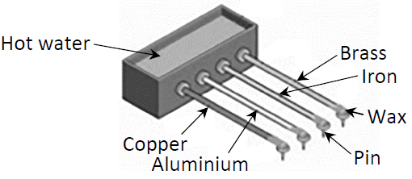
- Set up as shown
- Heat will travel from the source to the other end causing the wax to melt and the pin to fall.
- Whichever falls first is at the end of the best conductor.

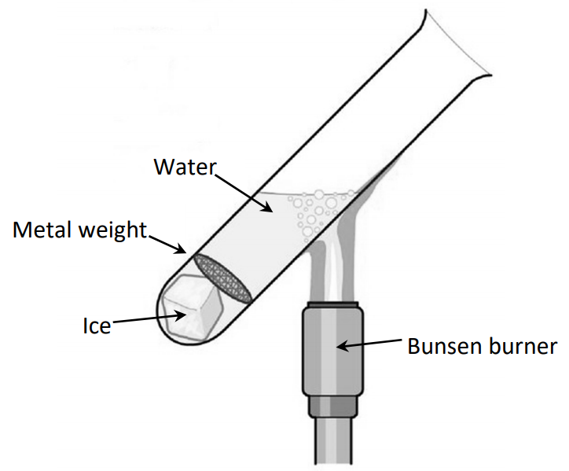
Demonstrating that water is a poor conductor of heat.
- Set the Bunsen burner under the top of the water.
- Observation: The ice at the bottom doesn’t melt even though the water at the top is boiling.
Conclusion: Water is a poor conductor (can you explain why?)

U-Values

The U-value of a house is a measure of the rate of heat loss to the surroundings.
U-Values are used in domestic situations to give an indication of how well a substance (roof, walls, tiles, etc) allows heat to flow (conduct) through it.
U-value is a measure of the heat flow through 1 m² of material each second when a temperature difference of 1 K exists between the two sides.

2014 Question 5 [Higher level]  The U-value of the material in a double-glazed window in a house is 2.8 W m^{–2} K^{–1}.  The window has an area of 3.0 m². How much energy is lost through the window in one hour if the temperature inside the house is 20 °C and the outside temperature is 11 °C? | The clue is in the unit. The U-value is 2.8 W m^{–2} K^{–1}.  This means 2.8 joules are lost every second per square meter for every one degree of a temperature difference.  We are interested in the heat lost through 3 m², over a period of one hour (3600 seconds) when the temperature difference is 9°.  So total heat lost = 2.8 × 3 × (3600) × 9  = 272160 J

Specific heat capacity

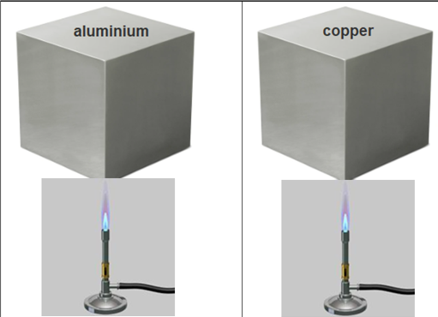
Specific heat capacity of water = 910 J kg⁻¹ K⁻¹ | Specific heat capacity of water = 390 J kg⁻¹ K⁻¹
The specific heat capacity of a substance is the change in heat energy associated with one kilogram of a substance heating up or cooling down by one kelvin.
The symbol for specific heat capacity is c.
Its unit is the joule per kilogram per kelvin (J kg⁻¹ K⁻¹).

So if specific heat capacity is the change in heat energy associated with one kilogram of a substance changing by one kelvin, it stands to reason that the total heat energy will be determined by the specific heat capacity multiplied by the total number of kilograms (which is just the mass) multiplied by the total number of degrees the temperature changes by.
In other words: change in heat energy = (specific heat capacity)(mass)(change in temperature)
For some reason the convention for the formula is to put the mass first so that it reads:

Q = (m)(c)(Δθ)

Q represents the change in heat energy
θ (representing change in temperature) is pronounced “delta theta”

Specific heat capacity – maths questions

$$Power=\frac{energy}{time}$$

2008 Question 7 (c) [Ordinary Level]
A saucepan containing 500 g of water at a temperature of 20 °C is left on a 2 kW ring of an electric cooker until it reaches a temperature of 100 °C.
All the electrical energy supplied is used to heat the water.
- Calculate the rise in temperature of the water.
- Calculate the energy required to heat the water to 100 °C.
- Calculate the amount of energy the ring supplies every second.
- Calculate the time it will take to heat the water to 100 °C.
(specific heat capacity of water = 4200 J kg⁻¹ K⁻¹)
Part (i) | 100 – 20 = 80 °C
Part (ii)  m = 0.5 kg  Δθ = 80 °C | Q = mcΔθ = (0.5)(4200)(80) = 168 000 J
Part (iii) | 2 kW = 2,000 W = 2,000 J per second.
Part (iv) | $power=\frac{energy}{time}$ $time=\frac{energy}{power}$ $time=\frac{168000}{2000}$ = 84 seconds
2013 Question 9 (b) [Ordinary Level]
A kettle contains 1.3 kg of water with a specific heat capacity of 4200 J kg⁻¹ K^{–1}.
The temperature of the water rises from 10 °C to 80 °C during a three-minute period.
- Calculate the energy gained by the water.
- Calculate the power rating of the kettle, assuming all of the electrical energy is used to heat the water.

Part (i)  m = 1.3 kg  Δθ = (80 – 10)  c = 4200 J kg⁻¹ K^{–1} | E = mcΔθ = (1.3)(4200)(70) = 382200 J
Part (ii) | $power=\frac{energy}{time}$ $power=\frac{382200}{180}$ = 2123.3 W

If joules are the unit of energy then what are calories?

2006 Question 7 (b) [Ordinary Level]
The total mass of the bricks in a storage heater is 80 kg and their specific heat capacity is 1500 J kg^{–1} K^{–1}.
During a ten-hour period the temperature of the bricks rose from 15 ºC to 300 ºC.
- Calculate the energy gained by the bricks.
- Calculate the power of the heating coil.

Part (i)  m = 80 kg  Δθ = (300 – 15)  c = 1500 J kg⁻¹ K^{–1} | E = mcΔθ = (80)(1500)(285) = 34 200000 J = 34.2 MJ
Part (ii) | $power=\frac{energy}{time}$ $power=\frac{34 200000 }{(10)(60)(60)}$ = 950 W
2006 Question 12 (c) [Higher Level]
400 g of water at a temperature of 15 ºC is placed in an electric kettle.
The power rating of the kettle is 3.0 kW.
- Calculate the energy required to raise the temperature of the water to 100 ºC.
- Calculate the energy supplied by the kettle per second.
- Calculate the least amount of time it would take to heat the water to 100 ºC.
(specific heat capacity of water = 4200 J kg^{–1} K^{–1})

Part (i)  m = 0.4 kg  Δθ = (100 – 15)  c = 4200 J kg⁻¹ K^{–1} | E = mcΔθ = (0.4)(4200)(85) = 142800 J = 1.428 x 10⁵ J
Part (ii) | 3.0 kW corresponds to 3000 J of energy supplied per second
Part (iii) | $time taken=\frac{Energy required to heat the water}{rate at which energy is supplied}$  $time=\frac{1.428×{10}^{5}}{3000}$ = 47.6 seconds
How much energy is required to raise the temperature of 500 litres of water from 20 ⁰C to 50 ⁰C?
specific heat capacity of water = 4200 J kg^{–1} K^{–1} density of water = 1000 kg m^{–3} 1 litre = 10^{–3} m³

c = 4200 J kg^{–1} K^{–1}
Δθ = (50 – 20) = 30 ⁰C
Mass of water:
We have 500 litres of water and each litre is 1 × 10^{–3} m³ so our total volume is 500 × 10^{–3} m³
$density= \frac{mass}{volume}$ therefore mass = (density)(volume) = (1000)(500 × 10^{–3}) = 500 kg.

Q = mcΔθ = (500)(4200)(30) = 6.3 × 10⁷ J

Heat capacity
The heat capacity of a substance is the heat energy needed to change the temperature of the substance by one kelvin.

The symbol for heat capacity is C (capital c; small c is the symbol for specific heat capacity).
The unit of heat capacity the joule per kelvin (J K⁻¹).
Q = C Δθ

Change in heat energy = (heat capacity)(change in temperature)

Storage heaters
- In an electric storage heater, bricks with a high heat capacity are heated overnight when electricity costs are low (if you’re on a ‘night rate’) by passing an electric current through a heating coil in the bricks.
- The bricks are surrounded by insulation (eg fibre glass) to minimise heat loss.
- The system is closed in but has a cover which can be opened to release the heat slowly when needed.
- Because the bricks have a high heat capacity they can absorb a lot of heat without increasing very much in temperature, therefore minimising heat lost back to the environment until the cover is opened.

- Note that heat moves from the heating coil through the bricks via conduction but once the cover is open the heat is transferred via moving air currents (convection) along with radiation directly from the surface of the heater.

2022 Question 11 [Higher level]
During the Bronze Age in Ireland, a fulacht fiadh was used to heat water, perhaps to cook food.
A particular fulacht fiadh contained 750 litres of water at an initial temperature of 4 °C.
50 stones were taken from the fire, at a temperature of 280 °C, and placed into the water.
The stones had an average heat capacity of 8.5 kJ K^{–1} each.
Calculate the highest temperature the water could have reached.
(for water at 4 °C, 1 litre = 1 kg; specific heat capacity of water = 4180 J kg^{–1} K^{–1})

Solution
Notes
- The key to this question is that the heat lost by the stones = the heat gained by the water.

- The second assumption is that the stones and the water will be at the same temperature at the end.

- In this case we are given the heat capacity of the stones – this is represented by capital ‘C’, whereas for the water we are given its specific heat capacity – represented by lower case ‘c’.

Heat lost by the stones
Heat capacity of each stone = 8.5 kJ K⁻¹ = 8500 J K⁻¹.
The initial temperature of the stones is 280 °C and they cool to some unknown final temp X °C.
Δθ = (285 – X)
Heat lost by each stone = (heat capacity)(change in temperature) = (C)(Δθ)
Total heat lost = (50)(C)(Δθ) = (50)(8500)(280 – x)

Heat gained by the water
There are 750 litres of water and each litre = 1 kg, so total mass of water = 750 kg
Specific heat capacity of water = 4180 J kg^{–1} K^{–1}
The initial temperature of the stones is 4 °C and they heat up to some unknown final temp X °C.
Δθ = (X - 4)

Heat energy lost by stones = heat energy gained by water
(mCΔθ)_{stones} = (mcΔθ)_{water}
(50)(8500)(280 – X) = (750)(4180)(C – 4)
X = 36.95 °C

Latent heat

latent heat curve
Look at the following graph of temperature versus heat absorbed for water:
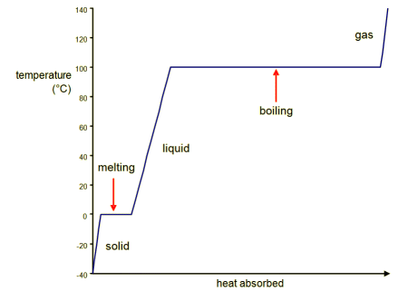

Stage1 | As heat is absorbed we note that the temperature rises from -40 ⁰C to 0 ⁰C
State 2 | At the melting point the energy taken in is used to change the state of the substance from solid to liquid rather than causing an increase in temperature. Hence the term latent (meaning hidden) heat.
Stage 3 | Once all the substance has changed state the temperature begins to rise again. This continues up until the water has reached 100 ⁰C.
State 4 | At the boiling point of water the energy taken in is used to change the state of the substance from liquid to gas rather than causing an increase in temperature.
Stage 5 | Once all the substance has changed to a gas the temperature begins to rise again.

2022 Question 8 [Ordinary Level]
Explain why a steam burn is more dangerous than a burn from boiling water. {Cracking question, but a bit tricky for Ordinary Level}
Solution
1 kg of water vapour at 100 ⁰C has more energy than 1 kg of boiling water which is at the same temperature (2.23×10⁶ joules more to be precise). This is because the steam also contains the extra heat required to change it from a liquid to a gas – and it is this (hidden or latent) heat which is absorbed by your skin if the water vapour condensed on it.

The unit of specific latent heat is the joule per kilogram (J kg⁻¹).
Note that there is no reference to the kelvin in this unit - this is because there is no temperature change when the substance is changing stage.

The specific latent heat of vaporisation of water = 2.23×10⁶ J kg^{–1}
The specific latent heat of fusion of water = 3.3 x10⁵ J kg^{–1}
The specific latent heat of a substance is the amount of heat energy taken in or released when 1 kg of the substance changes from one state to another without a change in temperature.

The specific latent heat of fusion (l_{f}) of a substance is the amount of heat energy taken in or released when 1 kg of the substance changes from a solid to a liquid (or vice versa) without a change in temperature.

The specific latent heat of vaporisation (l_{v}) of a substance is the amount of heat energy taken in or released when 1 kg of the substance changes from a liquid to a gas (or vice versa) without a change in temperature.

Latent heat – maths questions

The specific latent heat of a substance is the amount of heat energy taken in or released when 1 kg of the substance changes from one state to another without a change in temperature.
Q = (m)(l)

Heat needed to change state = (mass)( specific latent heat)

2022 Question 8 [Ordinary Level]
Ice has a latent heat of 330000 J kg^{–1}.
Calculate how much energy is required to change 0.2 kg of ice to water.

m = 0.2 kg  330000 J kg^{–1} | Q = ml = (0.2)(330000) = = 66000 J
2012 Question 9 (b) [Ordinary Level]
20 g of ice cubes at 0 °C are added to a glass of warm water.
All the ice melts quickly and cools the water to 5 °C.
- Calculate the energy required to melt the ice.
- Calculate the energy required to warm the melted ice to 5 °C.

specific heat capacity of water = 4180 J kg⁻¹ K⁻¹ ;
specific latent heat of fusion of ice = 3.34 × 10⁵ J kg⁻¹

Part (i)  m = 20 ×10⁻³ kg  l = 3.34 ×10⁵ J kg⁻¹ | Q = ml = (20 ×10⁻³)(3.34 ×10⁵) = 6.68 ×10³ J
Part (ii)  m = 20 ×10⁻³ kg  c = 4.18 ×10³ J kg⁻¹ K⁻¹  Δθ = (5 – 0) = 5 °C | Q = mcΔθ = (20×10⁻³)(4.18 ×10³)(5) = 418 J

2016 Question 9 [Ordinary Level]
A glass bottle is filled with 0.75 kg of water at a temperature of 20 ⁰C.
The bottle is then placed in a freezer, which freezes the water and cools it to −15 ⁰C.
- Calculate the energy removed from the water to reduce its temperature to 0 ⁰C.
- Calculate the energy removed from the water to convert the water at 0 ⁰C to ice at 0 ⁰C.
- Calculate the energy removed from the water to cool the ice at 0 ⁰C to ice at −15 ⁰C.
- The power rating of the freezer is 300 W.
How long will it take for the freezer to remove 9000 J of energy from the water?
- As the water freezes, the glass bottle cracks and shatters. Explain why this occurs.
Specific heat capacity of water = 4200 J kg^{–1} K^{–1}
Specific latent heat of fusion of water = 3.3 x10⁵ J kg^{–1}
Specific heat capacity of ice = 2200 J kg^{–1} K^{–1}

- Q = mcΔθ = 0.75 × 4200 × 20 = 63000 J
- Q = ml = 0.75 × (3.3 × 10⁵) = 247500 J
- Q = mcΔθ = 0.75 × 2200 × 15 = 24750 J
- $P=\frac{Work}{time}$ $time=\frac{Work}{power}$ $time=\frac{9000}{300}$ time = 30 s
- The water expands as it cools below 4 ⁰C.

2018 Question 8 [Higher Level]
In a nuclear reactor core, 5000 kg of water is heated so that its temperature increases by 70 K and it is converted into steam. Calculate the energy absorbed by the water.
shc of water = 4180 J kg^{–1} K^{–1}, specific latent heat of vaporisation of water = 2.23 × 10⁶ J kg^{–1}

Energy absorbed = energy required to heat water by 70 K + energy required to convert water to steam
= (mcΔθ) + (ml)_{steam}
= (5000)(4180)(70) + (5000)(2.23×10⁶)

= 1.26 ×10¹⁰ J

2012 Question 12 (c) [Higher Level]
The graph shows the variation in temperature θ of 150 g of crushed ice when it was supplied with energy ΔE at a constant rate.
Using the graph, estimate the specific latent heat of fusion of ice.

Solution

From the graph: the energy required to melt 0.15 kg of ice = (59 kJ – 10 kJ) = 49 kJ = 49000 J

Q = 49000 J m = 0.15 kg Q = ml

$l=\frac{Q}{m}= \frac{49000}{0.15}$ l = 3.27 × 10⁵ J Kg⁻¹

The heat pump
The heat pump is a device that extracts available heat from a cold area and transfers it to a warmer area.
Examples:
1. Refrigerator
2. Perspiration

How a heat pump works (a fridge contains a heat pump)
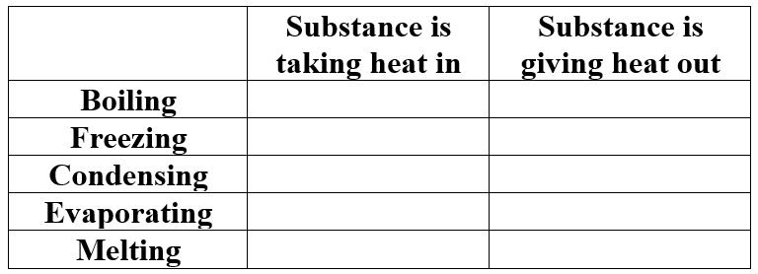
First let’s do a quick tick the box activity:
Operation
- The section on the left (in blue) below is inside the fridge; the section on the right (in red) is at the back of the fridge. Just like it says.

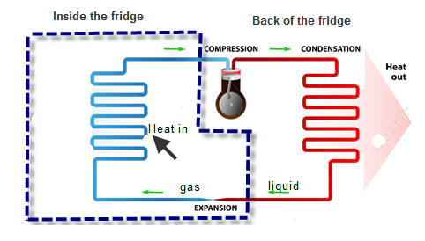
- A special liquid is pumped around the pipe as shown.
In order to help to figure out how it works, note the following.

- At the bottom of the diagram just above the blue dotted line is an expansion valve. This allows the liquid to expand quickly and in doing so it goes from a liquid to a gas and as it does it takes in energy from the environment outside the pipe. This pipe is inside the fridge so the air in that section cools down.

- At the top of the circuit outside the blue dotted line a pump is used to compress the gas which causes it to go back into a liquid state, and in the process it gives heat energy back out to the surroundings.

- Note that this liquid should have a high specific latent heat of vaporisation and low boiling point – can you say why?

Evolution, sweat and latent heat
The reason we perspire is to cool down – everybody knows that, but how does it work?

Humans are among a small group of animals that can produce sufficiently large amounts of sweat to keep cool (horses are another). Other animals have to let their tongue hang out but losing heat in this manner takes much longer so these animals have to stop every so often if hunted as prey, which allows humans to use ‘persistence hunting’ to run down their prey. The animal (like an antelope) is obviously quicker over short distances but over long periods and distances the antelope needs to stop and pant in order to cool, so by keeping their prey on the move it eventually gets to the stage where it collapses from heat exhaustion. These hunts can take 2 – 7 hours of persistence running and cover 25 miles (it also works best if the temperature is over 32 ⁰C). A successful hunt would typically end with the animal simply keeling over from exhaustion.An interesting side effect is that we lose salt, hence our craving for it. That’s mad that is.

It’s not obvious, but we act as a very large reservoir of heat, and when a drop of water forms on our skin it absorbs some of this heat energy from the skin and evaporates (turns to a gas). Water has quite a high latent heat value; one drop of sweat absorbs a lot of heat before it evaporates. The implications for this could not be greater. It explains why humans are one of the few mammals which don’t have fur – can you think why this was so important?
On the other hand if the humidity is high then sweat just runs off us and we don’t cool down nearly as much – overheating can result. This is going to be a considerable problem with increased global warming, and as usual it will hit poorer countries hardest.

Latent heat also explains why we feel so cold when we get out of a swimming pool; it’s the water evaporating off of us, but why don’t we feel as cold when we’re in the pool even though the temperature of the water is a lot lower than the temperature of the surrounding air?

How to get water from petrol
This technique was (supposedly) used by soldiers in the desert.
Suspend a small metal pail over a larger bucket. Pour petrol into the small pail. As the petrol evaporates it cools down the pail. Water vapour from the air now condenses on the outside of the pail and drips into the larger bucket.

Contrary to common wisdom, getting caught in a shower of rain will not lead to you catching a cold. After all, a cold is caused by a virus and last time I checked rain was composed of H₂O molecules, not viruses. The most likely reason for the link is the time of year; it rains more in winter and people are more likely to be inside – hence a greater likelihood of passing the cold on from person to person. But if there was to be a link, could latent heat have a role to play, and if so, what would it be?

How do hurricanes pick up energy?
Hurricanes only develop over warm water. For water to evaporate it must take in energy. This is happening constantly in our oceans (so the ocean would rapidly cool down if it in turn wasn’t gaining heat energy elsewhere) but the effect is most noticeably in warm waters, which is why we don’t get many hurricanes on this side of the Atlantic Ocean. Low atmospheric pressure also aides the process (can you remember why?).
As the water vapour rises it gets colder and eventually condenses releasing the stored latent heat to nearby molecules which increases their molecular kinetic energy. So air moves a lot faster. So the ocean is in effect ‘fuelling’ the hurricane. If the hurricane then moves over land it loses this energy supply and will dissipate.

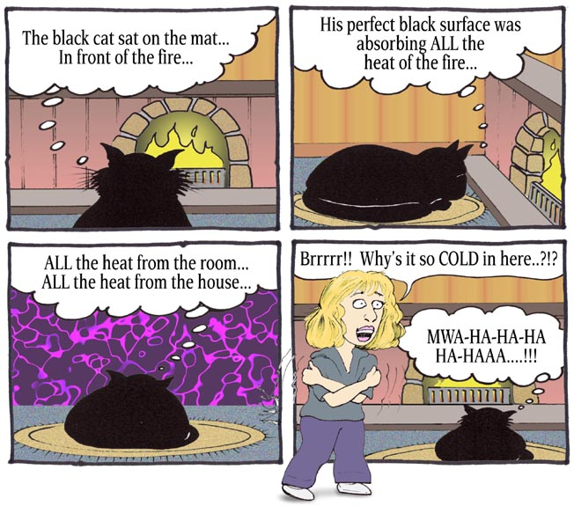
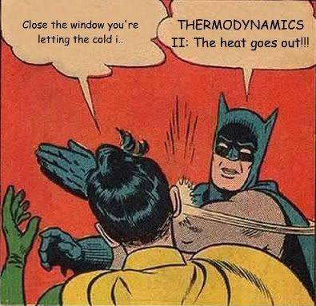

Mandatory Experiment: MEASUREMENT OF SPECIFIC HEAT CAPACITY OF WATER

APPARATUS
Power supply, joulemeter, heating coil, calorimeter, thermometer, electronic balance.

PROCEDURE
This experiment is built around the following equation:

Energy supplied via the heating coil = energy absorbed by calorimeter + energy absorbed by the water
Energy supplied = (mcΔθ)_{cal} + (mcΔθ)_{water}

So in order to find the specific heat capacity of water (c_{water}) we just need to find a value for everything else in the equation above and then use some straightforward algebra to get what we’re looking for.
Note that c_{cal} (the specific heat capacity of the metal which the calorimeter is made from) will be supplied.

- Find the mass of the water by first measuring the mass of the empty calorimeter, then the mass of the calorimeter with water in it, and subtracting one form the other.
- Set up the apparatus as shown in the diagram (with a power supply connected to the joulemeter).
- Record the initial temperature of the water (we assume this to be the same temperature as the calorimeter).
- Switch on the power supply
- Allow the temperature of the water to rise by approximately 10 degrees.
- Switch off the power supply.
- Note the reading on the joulemeter (this corresponds to the total energy supplied).
- Note the final temperature of the water (which also corresponds to the final temperature of the calorimeter).
- Calculate the specific heat capacity of water (c_{water}) using the equation above.

****************************************************************

RESULTS
Mass of calorimeter:

Mass of calorimeter + water:

Mass of water:

Initial temperature of water (and calorimeter):

Final temperature of water (and calorimeter):
Joulemeter reading:

Change in temperature Δθ:

CALCULATIONS

Energy supplied = (mcΔθ)_{cal} + (mcΔθ)_{water}

Final answer: specific heat capacity of water = ________________

PRECAUTIONS
- Ensure that the calorimeter is well insulated to avoid loss of heat energy.
- Stir the water throughout the experiment to ensure that the thermometer reading reflects the heat supplied.
- Use a sensitive thermometer graduated to 0.1 or 0.2 degrees. An error of 1 deg. in 10 is a large percentage error.
- Ensure that the heating element is covered with water to avoid any loss of heat energy.

Theory questions

Draw a labelled diagram of the apparatus used. | See notes
What measurements did the student take during the experiment? | Mass of calorimeter, mass of calorimeter plus water,  Initial and final temperatures.
Give a formula used to calculate the specific heat capacity of the substance. | Energy supplied = (mcΔθ)_{cal} + (mcΔθ)_{water} where Δθ is the change in temperature and c_{cal} is known.
Describe how the copper was heated and how its temperature was measured. | It was heated using a hot-plate and temperature was measured using a thermometer.
Give two precautions that were taken to minimise heat loss to the surroundings. | Insulate calorimeter /use lid /transfer copper pieces quickly / use cold water (below room temperature) / polish calorimeter / low heat capacity thermometer,  repeat and get an average, insulate, etc.
Explain why adding a larger mass of copper would improve the accuracy of the experiment. | A larger mass of copper would result in a larger temperature change and therefore smaller percentage error .

Related exam questions
OL: 2010, 2004 HL: 2007

[2010 OL]
A student carried out an experiment to measure the specific heat capacity of a substance.
The following is an extract from her report.
“I set up the apparatus. I took a series of measurements before I heated the substance. I then took further measurements. I used these measurements to find the specific heat capacity of the substance.”

- Draw a labelled diagram of the apparatus used in the experiment.
- Describe how the mass of the substance was determined.
- What other measurements did the student take during the experiment?
- Give the formula used to calculate the specific heat capacity of the substance.
- Give a precaution that the student should have taken to get an accurate result.

[2004 OL]
In a report of an experiment to measure the specific heat capacity of a substance (e.g. water or a metal), a student wrote the following.
“I assembled the apparatus needed for the experiment.
During the experiment I took a number of measurements of mass and temperature.
I used these measurements to calculate the specific heat capacity of the substance.”
- Draw a labelled diagram of the apparatus used.
- What measurements of mass did the student take during the experiment?
- What temperature measurements did the student take during the experiment?
- Give a formula used to calculate the specific heat capacity of the substance.
- Give one precaution that the student took to get an accurate result.

[2007]
mass of calorimeter 55.7 g
mass of calorimeter + water 101.2 g
mass of copper + calorimeter + water 131.4 g
initial temperature of water 16.5 ºC
temperature of hot copper 99.5 ºC
final temperature of water 21.0 ºC
This was not the method most students would have used to carry out the experiment so there was much annoyance when it appeared on the paper. Nevertheless it does differentiate between those students who understand the underlying principles and those who have just learned off a formula.
The specific heat capacity of water was found by adding hot copper to water in a copper calorimeter.
The following data was recorded:

- Describe how the copper was heated and how its temperature was measured.
- Using the data, calculate the energy lost by the hot copper.
- Using the data, calculate the specific heat capacity of water.
- Give two precautions that were taken to minimise heat loss to the surroundings.
- Explain why adding a larger mass of copper would improve the accuracy of the experiment.
(specific heat capacity of copper = 390 J kg^{–1} K^{–1})

Solution to 2007 maths part

- Using the data, calculate the energy lost by the hot copper

Mass of copper
Mass of copper = [(mass of calorimeter + copper) – (mass of calorimeter)]
= [131.4 g – 101.2g]
Mass of copper = 30.2 g = 0.0302 kg

c_{opper} = 390 J kg K⁻¹

Δθ_{copper}
The initial temperature of the hot copper was 99.5 ºC. We are told that the final temperature of the water was 21.0 ºC. However this is the temperature of the water plus copper and we can assume that both were at the same temperature so the final temperature of the copper was therefore also 21.0 ºC.
Δθ_{copper} = (99.5 – 21.0) = 78.5 K
Q = mcΔθ
Q = (0.0302)(390)(78.5)
Q = 924.6 J

Note that if we had a term involving mass on both sides of the equation then we could have kept everything in grams, but the left hand side was Q which is energy (and the unit of energy is joules). Anytime we are using an expression with different variables we need to keep everything in S.I. units, and the S.I. unit for mass is kg.
- Using the data, calculate the specific heat capacity of water.

We will be using the following equation:
Heat lost by hot copper = heat gained by calorimeter + heat gained by water
Heat lost by hot copper = (mcΔθ)_{calorimeter} + (mcΔθ)_{water}

Heat lost by hot copper = 924.6 J

===============================

m_{waterr} = [(mass of calorimeter + water) – (mass of calorimeter)]
= [101.2 g - 55.7 g] = 45.5 g = 0.0455 kg

c_{water} = specific heat capacity of water = ?
Δθ_{water} = change in temp of water = [21.0 ºC - 16.5 ºC] = 4.5 ºC

===============================
m_{calorimeter} = mass of copper calorimeter = 55.7 g = 0.0557 kg
c_{copper} = specific heat capacity of copper = 390 J kg K⁻¹
Δθ_{calorimeter} = change in temperature of calorimeter. Here we assume that because copper is a good conductor it will be at the same temperature as the water throughout, so change in temperature of the copper calorimeter = change in temperature of the water = 4.5 ºC

Heat lost by hot copper = heat gained by water + heat gained by calorimeter

924.57 = (0.0455)(c_{water})(4.5) + (0.0557)(390)(4.5)
924.57 = 0.2048 c_{water} + 97.75

c_{w} = 4.04 ×10³ J kg⁻¹ K⁻¹

Mandatory Experiment: MEASUREMENT OF THE SPECIFIC LATENT HEAT OF FUSION OF ICE

APPARATUS:
Ice, water, calorimeter, lagging, beakers, kitchen paper, thermometer and electronic balance.

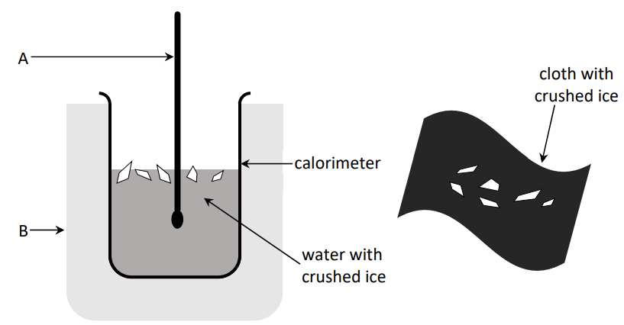

This experiment is built around the following equation:

Heat lost by calorimeter  +  heat lost by water | = | Heat gained by ice turning to water  +  heat gained by melted ice

(mcΔθ)_{cal} + (mcΔθ)_{water} = (ml)_{ice} + (mcΔθ)_{melted ice}

So in order to find a value for the latent heat of fusion of ice (l_{ice}) we just need to find a value for everything else in the equation above and then use some straightforward algebra to get what we’re looking for.
Note that values for c_{cal} and c_{water} will be supplied.

PROCEDURE
- Find the mass of the calorimeter.
- Half fill the calorimeter with water.
- Find the combined mass of the calorimeter and water. The mass of the water can be calculated by subtraction.
- Record the initial temperature (θ_{initial}) of the calorimeter plus water.
- Fire in some crushed, dried ice. Keep at it in until the temperature of the water has fallen by about 10 °C.
- Find the combined mass of the calorimeter plus water plus crushed ice. The mass of the ice can be calculated by subtraction.
- Take a note of the lowest temperature reached (θ_{final})
- Use the equation above to calculate a value for the latent heat of fusion of ice.

RESULTS
Mass of calorimeter:
Mass of calorimeter plus water:
Room temperature:
Temperature of ice:
Initial temperature of water (θ_{initial}):
Final temperature of water (θ_{final}):
Mass of calorimeter plus water plus ice:

CALCULATIONS
The rise in temperature of the ice (θΔ_{melted ice}) = θ_{final} – 0 °C . . . . . . . . . . .

The fall in temperature of the calorimeter (Δθ_{cal}) = is θ_{initial} – θ_{final} . . . . . . . . . . . .

The fall in temperature of the water (Δθ_{water}) = is θ_{initial} – θ_{final} . . . . . . . . . . . .

Mass of water:

Mass of ice:

(mcΔθ)_{cal} + (mcΔθ)_{water} = (ml)_{ice} + (mcΔθ)_{melted ice}

Final answer: specific latent heat of fusion of ice = ________________

PRECAUTIONS
- Ensure that the ice is dried (dab it with tissue paper) before adding to the calorimeter.
- Use a well insulated calorimeter to avoid loss or gain of heat to the surroundings.
- Stir well and record the lowest temperature when all of the ice has melted.

Theory questions

Draw a labelled diagram of the apparatus used. | See notes
What measurements did the student take before adding the ice to the water? | Initial temperature of the water  Mass of calorimeter  Mass of calorimeter plus water
What did the student do with the ice before adding it to the water? | Dried it with a paper towel
How did the student know the ice was at 0 ⁰C? | It was melting
How was the ice crushed? | Using a hammer, heavy weight, ice crusher etc
Why was the ice crushed? | to ensure it was all at the same temperature / to ensure it was all at 0°C / so that it would melt faster / to give a greater surface area
Why was dried ice used? | To ensure that only ice (and no water drops) were added to the calorimeter. Our equation assumes that only ice was added.
How was the ice dried? | Using a paper towel
Why was melting ice used? | To ensure that the ice was at 0°C
How did the student find the mass of the ice? | Final mass of (calorimeter plus water plus ice) – mass of (calorimeter plus water)
Why did the student use warm water in the experiment? | So that the heat lost to the environment when the system is above room temperature cancels out the heat taken in from the environment when the system is below room temperature / ice would melt more quickly
Give one precaution that the student took to get an accurate result. | Insulated the calorimeter/covered the calorimeter
Why was the experiment repeated? | To improve overall accuracy
Calculate the energy lost by the calorimeter and the warm water. | See solutions
Why could using a very large mass of water lead to a less accurate result in this experiment? | It would result in a change in temperature therefore greater percentage error.
What should be the approximate room temperature to minimise experimental error? | It should be half-way between initial and final temperatures of the water. You should also work this out mathematically.
What was the advantage of having the room temperature approximately halfway between the initial and final temperature of the water? | So that the heat lost to the environment when the system is above room temperature cancels out the heat taken in from the environment when the system is below room temperature.
The accepted value for the specific latent heat of fusion of ice is 3.3 × 10⁵ J kg⁻¹; suggest two reasons why your answer is not this value. | Thermometer not sensitive enough, lack of insulation, lack of stirring, heat loss/gain to surroundings, too long for ice to melt, inside of calorimeter tarnished, splashing, heat capacity of thermometer

Related exam questions
HL: 2019, 2008, 2002 OL: 2014, 2013, 2009, 2003

Specific heat capacity of copper = 390 J kg^{–1} K^{–1}
Note that in some questions the specific heat capacity of water is given as 4180 J kg^{–1} K^{–1}.
Other times it is given as 4200 J kg^{–1} K^{–1}.

[2019]
In an experiment to determine the specific latent heat of fusion of ice, a student first crushed some ice.
She then dried the melting ice before adding it to warm water in an insulated copper calorimeter.
The following data were recorded.
Mass of copper calorimeter = 56.3 g
Mass of calorimeter and water before adding ice = 108.5 g
Initial temperature of water = 29.5 °C
Final temperature of water = 8.0 °C
Mass of calorimeter and water after adding ice = 122.9 g
(specific heat capacity of water = 4180 J kg^{–1} K^{–1})

- Why did the student crush the ice?
- Why did the student dry the ice?
- How was the ice crushed?
- How was the ice dried?
- Why did she use warm water?
- Why did she use melting ice?
- Use the data to calculate the specific latent heat of fusion of ice.
- Why could using a very large mass of water lead to a less accurate result in this experiment?

[2008]
In an experiment to measure the specific latent heat of fusion of ice, warm water was placed in a copper calorimeter. Dried, melting ice was added to the warm water and the following data was recorded.
Mass of calorimeter 60.5 g
Mass of calorimeter + water 118.8 g
Temperature of warm water 30.5 ºC
Mass of ice 15.1 g
Temperature of water after adding ice 10.2 ºC
(specific heat capacity of water = 4200 J kg^{–1} K^{–1})

- Explain why warm water was used.
- Why was dried ice used?
- Why was melting ice used?
- Describe how the mass of the ice was found.
- What should be the approximate room temperature to minimise experimental error?
- Calculate the energy lost by the calorimeter and the warm water.
- Calculate the specific latent heat of fusion of ice.

Calculations

2019
In each of these questions our first line contains a term for mass so we can leave all mass in grams to save us converting to kg (it’s as if we did convert to kg but then divided each term by 1000, and once you do the same to each term it doesn’t change the final answer). But for the unbelievers we will do this question both ways.

First we will leave all masses in grams:

Heat energy lost by calorimeter  +  heat energy lost by water | = | Heat energy gained by ice turning to water  +  heat energy gained by melted ice

(mcΔθ)cal + (mcΔθ)warm water = (ml)ice + (mcΔθ )melted ice

(56.3)(390)(21.5) + (52.2)(4180)(21.5) = (14.4)l + (14.4)(4180)(8)

472075.5 + 4691214 = (14.4)l + 481536

l = 3.25 × 10⁵ J kg⁻¹

Now just to show that we will get the same answer if we express all mass in kg:

(mcΔθ)cal + (mcΔθ)warm water = (ml)ice + (mcΔθ )melted ice

(0.0563)(390)(21.5) + (0.0522)(4180)(21.5) = (0.0144)l + (0.0144)(4180)(8)

472.0755 + 4691.214 = (14.4)l + 481.536

l = 3.25 × 10⁵ J kg⁻¹

Note that in both cases not only is our answer the same but the unit is the same: J kg⁻¹

2008
In this solution we convert all masses to kg but we have left everything in grams if we wished

Heat energy lost by calorimeter  +  heat energy lost by water | = | Heat energy gained by ice turning to water  +  heat energy gained by melted ice

(mcΔθ)cal + (mcΔθ)warm water = = (ml)ice + (mcΔθ )melted ice

(0.0605)(390)(20.3) + (0.0583)(4200)(20.3) = (0.0151)l + (0.0151)(4200)(10.2)

5449.6 = 0.0151 l + 646.884

l = 3.181 × 10⁵ ≈ 3.2 × 10⁵ J kg^{–1}

Mandatory Experiment: MEASUREMENT OF SPECIFIC LATENT HEAT OF VAPORISATION OF WATER

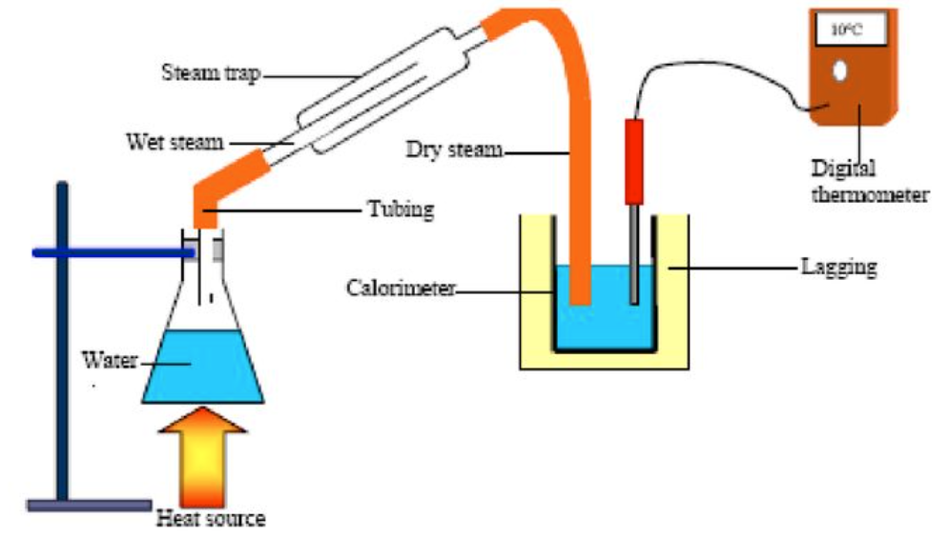
APPARATUS / DIAGRAM
Also electronic balance

This experiment is built around the following equation:

Energy lost_{by steam condensing to water}  +  energy lostby condensed steam cooling down | = | energy gained by calorimeter  +  energy gained by the water

(ml)_{steam} + (mcΔθ)_{condensed_steam} = (mcΔθ)_{cal} ₊ (mcΔθ)_{water}

So to find a value for the latent heat of vapouristaion of water (l_{steam}) we just need to find a value for everything else in the equation above and then use some straightforward algebra to establish l_{steam}.
Note that values for c_{cal} and c_{water} will be supplied.

PROCEDURE
- Find the mass of the empty calorimeter.
- Half fill the calorimeter with water.
- Find the mass of the water + calorimeter and by subtraction find the mass of the water.
- Record the temperature of the calorimeter plus water (θ_{initial})
- Boil the water in the flask until steam issues freely from the delivery tube.
- Allow dry steam to pass into the water in the calorimeter until the temperature has risen by about 20 °C, then remove the steam delivery tube from the water.
- Record the final temperature (θ_{final}) of the calorimeter plus water plus condensed steam.
- Find the mass of the calorimeter + water + condensed steam and by subtraction find the mass of the condensed steam.

RESULTS
Mass of the calorimeter........................... =
Mass of calorimeter plus cold water .................................. =
Initial temperature of water..................... =
Temperature of the steam........................ =
Final temperature of water ...................... =
Final mass of steam calorimeter plus water plus steam ............................... =

CALCULATIONS
Mass of cold water .................................. =

Mass of steam .................................. =

Δθ_{condensed_steam} = . . . . . . . .

Δθ_{cal} = . . . . . . . . . . . . .

Δθ_{water} = . . . . . . . . . .

(ml)_{steam} + (mcΔθ)_{condensed_steam} = (mcΔθ)_{cal} ₊ (mcΔθ)_{water}

Final answer: specific latent heat of vapourisation of water = ________________

PRECAUTIONS:
- Ensure that only steam (not water) enters the water in the calorimeter. Use a "steam trap" (it actually traps water) if available.
- Use a tilted insulated tube as an alternative delivery pipe for dry steam. This does away with the need to use a steam trap.
- Use a well-insulated calorimeter to avoid loss or gain of heat to the surroundings.

Theory questions

Draw a labelled diagram of the apparatus used. | 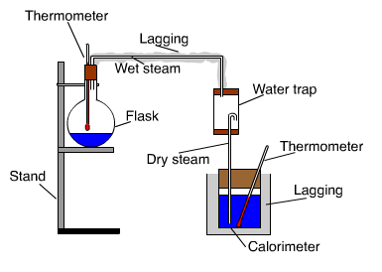
List two measurements that the student took before adding the steam to the water. | Mass of calorimeter, mass of water, mass of calorimeter + water, initial temperature of water, initial temperature of steam.
Describe how the mass of the cold water was found. | (mass of water + calorimeter) – (mass of calorimeter)
Describe how the mass of the steam was determined. | (mass of water + calorimeter + steam) – (mass of water + calorimeter)
How did the student make sure that only steam, and not hot water, was added to the calorimeter / How was the steam dried? | Allow steam to flow for some time before inserting it into water, slope delivery tube back to steam generator, use a steam trap.
Why was dry steam used? | The equation we use assumes that only dry steam is added.
How was the water cooled below room temperature? | Storing in a fridge in advance
Why was the water cooled below room temperature? | So that the heat lost to the environment when the system is above room temperature cancels out the heat taken in from the environment when the system is below room temperature.
What should the initial temperature of the water in the calorimeter be? | It should be half-way between initial and final temperatures of the water. You should also work this out mathematically.
Give one precaution that the student took to prevent heat loss from the calorimeter. | Insulated the calorimeter/cover the calorimeter
Why was a sensitive thermometer used? | For greater accuracy / to reduce (%) error /
A thermometer with a low heat capacity was used to ensure accuracy. Explain why. | It absorbs little heat from system in calorimeter and calculations assume that no energy is transferred to the thermometer.
Give two ways of improving the accuracy of this value | Lagging, insulation, lid, carry out measurements quickly, use a thermometer with a low heat capacity  Use a digital thermometer, use more steam, use less water, stirring, steam trap
Calculate the heat gained by the water and the calorimeter | See calculations
Calculate the heat lost by the condensed steam | See calculations

Related exam questions
HL: 2015, 2010, 2005, 2003 OL: 2015, 2011, 2005
Specific heat capacity of copper = 390 J Kg⁻¹ K⁻¹

[2010]
In an experiment to measure the specific latent heat of vaporisation of water, a student used a copper calorimeter containing water and a sensitive thermometer. The water was cooled below room temperature before adding dry steam to it. The following measurements were recorded.

Mass of copper calorimeter = 34.6 g
Initial mass of calorimeter and water = 96.4 g
Mass of dry steam added = 1.2 g
Initial temperature of calorimeter and cooled water = 8.2 °C
Final temperature of calorimeter and water = 20.0 °C
(specific heat capacity of water = 4180 J Kg⁻¹ K⁻¹)

- How was the water cooled below room temperature?
- How was the steam dried?
- Describe how the mass of the steam was determined.
- Why was a sensitive thermometer used?
- Using the data, calculate the specific latent heat of vaporisation of water.

[2005]
In an experiment to measure the specific latent heat of vaporisation of water, cool water was placed in an insulated copper calorimeter. Dry steam was added to the calorimeter. The following data was recorded.
Mass of calorimeter = 50.5 g
Mass of calorimeter + water = 91.2 g
Initial temperature of water = 10 ºC
Temperature of steam = 100 ºC
Mass of calorimeter + water + steam = 92.3 g
Final temperature of water = 25 ºC
(specific heat capacity of water = 4200 J Kg⁻¹ K⁻¹)

- Calculate a value for the specific latent heat of vaporisation of water.
- Why was dry steam used?
- How was the steam dried?
- A thermometer with a low heat capacity was used to ensure accuracy. Explain why.

[2015]
This question is a little different from the others; instead of using a calorimeter which absorbs heat this time the student used a polystyrene cup. Polystyrene is good insulator so the assumption here is that it doesn’t absorb any heat.

In an experiment to measure the specific latent heat of vaporisation of water, cool water was placed in a polystyrene cup. Dry steam was then added to the water.
The following data were recorded.

Mass of polystyrene cup = 1.2 g
Initial mass of polystyrene cup and water = 84.6 g
Initial temperature of water = 11 °C
Temperature of steam = 100 °C
Final temperature of water = 30 °C
Final mass of polystyrene cup and water = 87.2 g
(specific heat capacity of water = 4180 J kg^{–1} K^{–1})

- Draw a labelled diagram of the apparatus used in the experiment.
- A student used these data to calculate the specific latent heat of vaporisation of water.
State two assumptions that the student made about the polystyrene cup when carrying out this calculation.
- Use the data given above to calculate the specific latent heat of vaporisation of water.
- The student ensured that (i) the steam had been dried and (ii) the water that was initially in the cup had been cooled.
How did each of these steps improve the accuracy of the experiment?

Solution to 2015

(i) Polystyrene cup with water, Steam generator, Point of detail (thermometer, steam trap, lagging, lid, mass balance, delivery tube)
(ii)
Heat lost by steam changing state + heat lost by condensed steam cooling down = heat absorbed by water

(ml)_{steam} + (mcΔθ)_{condensed_steam} = (mcΔθ)_{water}
Δθ_{condensed_steam} = 70 K
Δθ_{water} = 19 K
m_{s} = 0.0026 kg
m_{w} = 0.0834 kg

(0.0026 × l) + (0.0026)(4180)(70) = (0.0834)(4180)(19)
l = 2.25 × 10⁶ J kg⁻¹

(iii) That it is a good/perfect insulator /That it has a low/negligible heat capacity / specific heat capacity / that it does not gain heat

- Calculations assume that only steam is added / no water was added // Otherwise the steam would have lost its latent heat (of vaporisation)
(ii) Energy/heat gained = energy/heat lost

Solutions to calculation questions

2010

m_{steam} = 0.0012 kg
m_{water} = 0.0618 kg
m_{calorimeter} = 0.0346 kg

Δθ_{s} = 80 (K) and
Δθ_{w} (= Δθ_{cu}) = 11.8 K

Energy lost_{by steam condensing to water}  +  energy lostby condensed steam cooling down | = | energy gained by the water  +  energy gained by calorimeter

(0.0012)l + (0.0012)(4180)(80) = (0.0618)(4180)(11.8) + (0.0346)(11.8)(390)

(1.2 × 10⁻³)l + 401.3 = 3048.2 + 159.2

l = 2.34 × 10⁶ J Kg⁻¹

2005

m_{steam} = 0.0011 kg
m_{water} = 0.0407 kg
m_{calorimeter} = 0.0505 kg

Δθ_{s} = 75 ⁰C
Δθ_{w} (= Δθ_{c}) = 15 ⁰C

Energy lost_{by steam condensing to water}  +  energy lostby condensed steam cooling down | = | energy gained by the water  +  energy gained by calorimeter

(ml)_{s} + (mcΔθ)_{s} = (mcΔθ )_{w} + (mcΔθ )_{cal}

(0.0011) l_{w} + (0.0011)(4200)(75) = (0.0407)(4200)(15) + (0.0505)(390)(15)

[(0.0011) l_{w} + 346.5 = 2564.1 + 295.425]

l_{w} = 2.28 × 10⁶ J kg⁻¹

SLOP

Specific heat capacity of copper = 390 J kg^{–1} K^{–1}; Specific heat capacity of water = 4200 J kg^{–1} K^{–1}
s.h.c. of aluminium = 910 J kg⁻¹ K⁻¹; Specific latent heat of fusion of ice is 3.3 × 10⁵ J kg⁻¹
Specific latent heat of vaporisation of water = 2.3 × 10⁶ J Kg⁻¹

What is heat? | Heat is a form of energy
Name three methods by which heat can be transferred. | Conduction, convection and radiation.
Define conduction | Conduction is the movement of heat energy through a substance by the passing on of molecular vibration from molecule to molecule, without any overall movement of the substance.
Define convection | Convection is the transfer of heat through a fluid by means of circulating currents of fluid caused by the heat.
Define radiation
Explain how heat is transferred in a solid. | Atoms are touching / in contact so the heat/energy gets transferred from one to the other by vibration (without the atoms moving along).
Why are the pipes in the solar panel usually made from copper? | It is a good heat conductor.
Explain the term ‘U-value’. | The U-value of a house is a measure of the rate of heat loss to the surroundings.
What is the effect of increasing the U-value of a structure? | It means that the heat conductivity of the structure is increased.
Give two ways in which the U-value of a house can be reduced. | Fibreglass in attic, insulation in cavity wall, double glazing, carpets
Name a material that could be used as insulation in a storage heater. | Fibre glass / rockwool / cotton wool.
Why is the heating element of an electric kettle near the bottom? | To prevent heat-loss.
Explain how the storage heater heats the air in a room. | They are heated only at night but must release energy slowly during the day.
Storage heaters have a large heat capacity. Explain why. | So that they can absorb a lot of energy without increasing too much in temperature.
Why does warm water rise? | The air above it is now more dense and so sinks downwards and the warmer air underneath has no place to go but up!
Why are the pipes in the solar panel usually painted black? | Black is a good absorber of radiation.
Define specific heat capacity. | The specific heat capacity of a substance is the heat energy needed to change one kilogram of the substance by one Kelvin.
Define specific latent heat. | The specific latent of a substance is the amount of heat energy need to change the state of 1 kg of the substance without a change in temperature.
Why does the temperature of an athlete reduce when she perspires? | As the water evaporates it takes heat energy from the body.
Explain why snow is slow to melt as the day-time temperatures rises above 0 °C. | Latent heat of snow/ice (energy needed for change of state) is (very) large
Describe an experiment to demonstrate convection in a liquid.

TEMPERATURE AND HEAT EXAM QUESTIONS 2002 – 2022
Higher and Ordinary Level

Specific heat capacity of copper = 390 J kg^{–1} K^{–1};

Specific heat capacity of water = 4200 J kg^{–1} K^{–1}

Specific heat capacity of aluminium = 910 J kg⁻¹ K⁻¹;

Specific latent heat of fusion of ice is 3.3 × 10⁵ J kg⁻¹

Specific latent heat of vaporisation of water = 2.3 × 10⁶ J Kg⁻¹

Temperature: Ordinary level questions

2005 12 (a) [Ordinary Level]
To calibrate a thermometer, a thermometric property and two fixed points are needed.
- What does a thermometer measure?
- What are the two fixed points on the Celsius scale?
- Explain the term thermometric property.
- Name the thermometric property used in a mercury thermometer.
- Give an example of another thermometric property.

2008 Question 7 (a) [Ordinary Level]
The temperature of an object is measured using a thermometer, which is based on the variation of its thermometric property.
- What is meant by temperature?
- What is the unit of temperature?
- Give an example of a thermometric property.

2009 Question 12 (b) [Ordinary Level]
- What is meant by the temperature of a body?
- Name two scales that are used to measure temperature.
- What is the boiling point of water on each of these scales?
- The diagram shows a laboratory thermometer, what is its thermometric property?
- Name one other type of thermometer and state its thermometric of property.
- Why is there a need for a standard thermometer?

2011 Question 8 (a) [Ordinary Level]
- What is meant by a thermometric property?
- Name two different thermometric properties.
- Name two different thermometers.
- Describe how to calibrate a thermometer.
- Why is there a need for a standard thermometer?

2014 Question 7 (a) [Ordinary Level]
The temperature of an object can be measured using a thermometer which is based on a suitable thermometric property.
- What is heat?
- What is meant by temperature?
- Give an example of a thermometric property.
- The SI unit of temperature is the kelvin. Give another temperature scale.
- Express 310 K in the units of the scale you have named in part (iv).

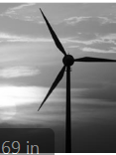
2020 Question 12 (b) [Ordinary Level]
A thermometer is used to measure temperature.
- What is meant by temperature?
- Body temperature is 37 °C. Convert this to kelvin (K).

A thermometer is based on a particular thermometric property.
- What is a thermometric property?
- Name one example of a thermometric property.
- An uncalibrated thermometer is one that has no markings or numbers on it.
Describe an experiment to calibrate a thermometer.

Temperature: Higher level questions

2003 Question 12 (b) [Higher Level]
- What is the difference between heat and temperature?
- The emf of a thermocouple can be used as a thermometric property.
Explain the underlined terms.
- Name a thermometric property other than emf.
- Explain why it is necessary to have a standard thermometer.

2015 Question 12 (c) [Higher Level]
- A thermometer uses a thermometric property to measure temperature.
The thermometric property of a thermocouple thermometer is emf.
Explain the underlined terms.
- What is the SI unit of temperature?
- Give an advantage of using this unit in scientific measurements.
- Describe a laboratory experiment to demonstrate the principle of operation of a thermocouple.
- Give an advantage of using a thermocouple thermometer instead of a mercury-in-glass thermometer.

2011 Question 7 (c) [Higher Level]
- A thermocouple is used to measure the temperature of the steam.
How would you demonstrate the principle of operation of a thermocouple?
- Describe how to establish a calibration curve for a thermocouple.

Question 9 Higher Level 2023
Voyager I and Voyager II are spacecraft that were launched in 1977 to investigate the outer planets of our solar system.
The spacecraft are powered with radioisotope thermoelectric generators.
When the spacecraft were launched, each generator contained 4 kg of plutonium–238.
- The energy released by the decay is converted into electrical energy in thermocouples.
State the thermometric property of a thermocouple.
- Draw a labelled diagram of the arrangement of a thermocouple.

2013 Question 12 (d) [Higher Level]
- What is meant by the term thermometric property?

This graph was obtained during an experiment where the resistance R of a thermistor was measured as its temperature θ was raised from 0 °C to 100 °C (as measured by a mercury-in-glass thermometer).

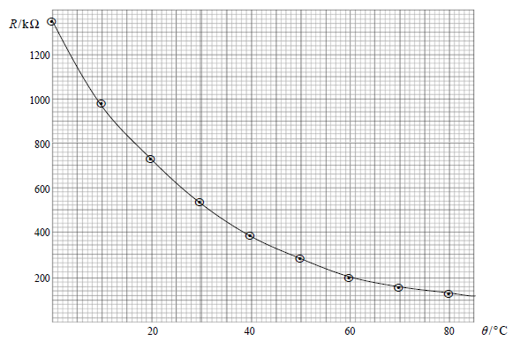

The thermistor is used in a circuit to keep the water in a tank at a constant temperature.
- What is the temperature of the water when the resistance of the thermistor is 420 kΩ?

- A thermocouple thermometer has emf values of 0 μV at 0 °C and 815 μV at 100 °C.
When the thermocouple thermometer was placed in the tank of water, its emf was found to be 319 μV.
What is the temperature of the water in the tank as measured by the thermocouple thermometer?
[I’m not sure this is a valid question, but in order to do it you need to assume that there is a linear relationship between emf and temperature]

- Why do the thermistor and the thermocouple thermometer give different temperature readings for the water in the tank?

Heat: Ordinary level theory questions

2013 Question 9 [Ordinary Level]
- When heat is transferred to or from an object the temperature of the object changes.
What is heat?
- Name the three ways in which heat can be transferred.
- Describe an experiment to show how heat is transferred in a liquid.
- The water in an electric kettle is heated by the element and its handle is made from an insulating material.
How does the method of heat transfer in a liquid affect the positioning of the heating element in a kettle?
- Why is the handle of a kettle made of an insulating material?
- Name an insulator suitable for use in the handle of a kettle.

2018 Question 7 [Ordinary Level]
The temperature of an object can be measured using a thermometer.
- What is heat?
- What is meant by the temperature of an object?
- What is the unit of temperature on the SI scale?
- Express 20 °C in the units you have named in part (iii).

The diagram shows an apparatus used to compare heat transfer in different metals.
- Name the method by which heat is transferred in metals.
- Name the two other methods of heat transfer.
- How can this experiment be used to find out which metal is the best at allowing heat transfer?
- State two ways of making sure that this investigation is fair.
- Metals are good conductors. Name a good insulator.

2014 Question 7 (b) [Ordinary Level]
The photograph shows an experiment to compare the heat transfer in different metals.
A piece of wood is placed in a drop of wax at the end of each piece of metal and a heat source is used to heat the metals at the centre of the apparatus.
- How is heat transferred in metals?
- Name the two other methods of heat transfer.
- How can this experiment be used to find out which of the metals is best at allowing heat transfer?
- State one way to make sure that this is a fair test.

2012 Question 9 (a) [Ordinary Level]
- The temperature of an object is a measure of its hotness or coldness.
What is the SI unit of temperature?
- The Celsius scale is the practical temperature scale.
How is the degree Celsius (°C) related to the SI unit of temperature?
- When heat is transferred to a substance, it causes a rise in temperature or a change in state of the substance, or both.
What is heat?
- Name the three methods of heat transfer.
- What is meant by the change in state of a substance?
- Define specific latent heat.

2010 Question 8 (a) [Ordinary Level]
- What is heat?
- Explain how heat is transferred in a solid.
- Describe an experiment to compare the rates of heat transfer through different solids.
- Explain the term U-value
- How can the U-value of the walls of a house be reduced?

2010 Question 8 (b) [Ordinary Level]
The diagram shows a solar heating system.
- How is the sun’s energy transferred to the solar collector?
- Why is the solar collector normally painted black?
- How is the heat transferred from the solar panel to the hot water tank?
- The heating coil for the hot water tank are placed at the bottom, explain why.
- Give an advantage and a disadvantage of a solar heating system.

2008 Question 7 (c) [Ordinary Level]
The rise in temperature of an object depends on the amount of heat transferred to it and on its specific heat capacity.
- What is heat?
- Name three ways in which heat can be transferred.
- Define specific heat capacity.

2006 Question 7 (a) [Ordinary Level]
- Heat can be transferred in a room by convection.
- What is convection?
- Name two other ways of transferring heat.
- Describe an experiment to demonstrate convection in a liquid.

- In an electric storage heater, bricks with a high specific heat capacity are heated overnight by passing an electric current through a heating coil in the bricks.
The bricks are surrounded by insulation.
Why is insulation used to surround the bricks?
- Name a material that could be used as insulation.
- Explain how the storage heater heats the air in a room.

2004 Question 7 [Ordinary Level]
- Heat can be transferred by conduction. What is meant by conduction?
- Name two other ways of transferring heat.
- Describe an experiment to show how different solids conduct heat at different rates.
- The U-value of a house is a measure of the rate of heat loss to the surroundings.
Give two ways in which the U-value of a house can be reduced.
- The diagram shows a solar panel (solar heater) which can be used in the heating of a house.
What energy conversion takes place in a solar panel?
- Why are the pipes in the solar panel usually made from copper?
- Why are the pipes in the solar panel usually painted black?
- Why does warm water rise to the top of the solar panel?

2021 Question 11 [Ordinary Level]
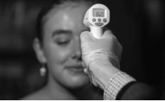
The normal human body temperature is 37 °C.
This temperature increases when a person is fighting an infection.
The thermometer in the photograph on the right measures infrared radiation emitted from a person’s forehead.
- Heat may be transferred by radiation and by conduction.
Name the other way in which heat may be transferred.
- Distinguish between heat and temperature.
- Convert the normal human body temperature from degrees Celcius (°C) into kelvin (K).
- Thermometers are designed to make use of thermometric properties.
What is a thermometric property?
- State one example of a thermometric property.
- Two thermometers may not give the same reading for a person’s temperature, even though both thermometers are working correctly. Explain why this is the case.
- The solar constant (solar irradiance) is a measure of how much radiation from the Sun falls on each square metre of the Earth’s surface in one second. It has a value of 1.36 kW m⁻².
- The diagram on the right shows a rectangular garden.
On a particular day, sunlight falls on the garden for exactly 12 hours.
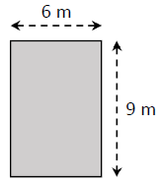
Calculate the area of the garden.
- Calculate how many seconds there are in 12 hours.
- Calculate how much energy will fall on the garden in the 12 hours.
- Heat is transferred at different rates depending on the material it is moving through.
Describe an experiment to compare the rate of conduction through different solids.
- U−value is a measure of the rate of heat loss through walls and windows.
Describe two ways of reducing heat loss from a building.

2023 Question 9 [Ordinary level]
Brick is considered one of the best construction materials in the world for a number of reasons. One reason is that brick is a better insulator than many other building materials.
- Heat is transferred through a wall by conduction. Name two other ways in which heat can be transferred.
- What is meant by the U-value of a material?
- A wall has an area of 66 m² and a U-value of 0.31 W m^{–2} K^{–1}. The temperature difference between inside and outside the wall is 15 °C. Calculate how much heat energy is transmitted through the wall every second.

Heat: Ordinary level questions involving specific heat capacity

2002 Question 12 (b) [Ordinary Level]
- Define specific heat capacity.
- An electric kettle contains 1.5 kg of water. The specific heat capacity of water is 4180 J kg⁻¹ K⁻¹.
Calculate the amount of energy required to raise the temperature of the water from 15 ⁰C to 100 ⁰C.
- The kettle takes 4 minutes to heat the water from 15 ⁰C to 100 ⁰C.
Calculate the power of the kettle. (Assume all the energy supplied is used to heat the water).
- Why is the heating element of an electric kettle near the bottom?

2013 Question 9 (b) [Ordinary Level]
A kettle contains 1.3 kg of water with a specific heat capacity of 4200 J kg⁻¹ K^{–1}.
The temperature of the water rises from 10 °C to 80 °C during a three-minute period.
- Calculate the energy gained by the water.
- Calculate the power rating of the kettle, assuming all of the electrical energy is used to heat the water.

2011 Question 8 (b) [Ordinary Level]
An electric kettle is filled with 500 g of water and is initially at a temperature of 15 ⁰C.
The kettle has a power rating of 2 kW.
- Calculate the energy required to raise the temperature of the water to 100 ⁰C.
- How much energy is supplied by the kettle every second?
- How long will it take the kettle to heat the water to 100 ⁰C?
- Name a suitable material for the handle of the kettle. Justify your answer.
(specific heat capacity of water = 4180 J Kg⁻¹ K⁻¹)

2018 Question 12 (c) [Ordinary Level]
The diagram shows a water boiler which is filled with 0.7 kg of water which is initially at 20 ⁰C.
The boiler has a power rating of 3 kW.
- Calculate the energy needed to raise the temperature of the water from 20 ⁰C to 90 ⁰C.
- How many joules of energy are supplied per second by the boiler?
- Calculate how long it will take the boiler to heat the water to 90 ⁰C.
- Where should the manufacturer place the heating element of the boiler? Explain your answer.
(specific heat capacity of water = 4200 J kg⁻¹ K⁻¹)

2015 Question 9 [Ordinary Level]
Distinguish between heat and temperature.
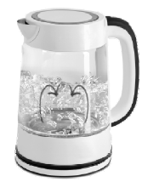
The diagram shows a kettle which is filled with 500 g of water which is initially at a temperature of 20 °C.
The heating element of the kettle has a power rating of 0.8 kW.
We assume all the heat is transferred to the water.
- Find the energy required to raise the temperature of the water to 100 °C.
- What is the energy supplied by the element per second?
- How long will it take the kettle to heat the water to 100 °C?
- Why are handles of kettles often made of plastic?
- How is the heat transferred throughout the liquid in the kettle?
- Why is the heating element of a kettle made of metal?
- The heat source for a kettle is placed at the bottom. Suggest why this is the case.
(specific heat capacity of water = 4180 J kg⁻1 K⁻¹)

2008 Question 7 (c) [Ordinary Level]
A saucepan containing 500 g of water at a temperature of 20 °C is left on a 2 kW ring of an electric cooker until it reaches a temperature of 100 °C.
All the electrical energy supplied is used to heat the water.
- Calculate the rise in temperature of the water;
- Calculate the energy required to heat the water to 100 °C;
- Calculate the amount of energy the ring supplies every second;
- Calculate the time it will take to heat the water to 100 °C.

2006 Question 7 (b) [Ordinary Level]
The total mass of the bricks in a storage heater is 80 kg and their specific heat capacity is 1500 J kg^{–1} K^{–1}.
During a ten-hour period the temperature of the bricks rose from 15 ºC to 300 ºC.
- Calculate the energy gained by the bricks;
- Calculate the power of the heating coil.

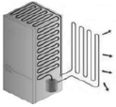
2017 Question 12 (b) [Ordinary Level]
- The heat pump in a fridge uses a fluid with a high specific latent heat.
Explain the underlined terms.
- A fridge lowers the temperature of 2 kg of water from 30 °C to 5 °C in 840 s.
Calculate the energy removed from the water.
- Calculate the power of the fridge.
(specific heat capacity of water = 4200 J kg⁻¹ K⁻¹)

2019 Question 8 [Ordinary Level]
A student measured the temperature of a large bath full of water and a small cup full of water and said “they are both at the same temperature, so they must contain the same amount of energy”.
- Is the student’s statement correct? Explain your answer.
- The thermometric property used by a mercury thermometer is the length of a column of liquid.
What is meant by a thermometric property?
- Name another example of a thermometric property.
- A storage heater consists of an electric heater surrounded by bricks made of a material with a high specific heat capacity.
Define specific heat capacity.
- Why does the material in the bricks need to have a high specific heat capacity?
- A kettle supplies heat to 1.5 kg of water and raises its temperature from 15 °C to 88 °C.
Calculate the heat energy gained by the water in the kettle.
- If heat energy continues to be supplied, the water will reach its boiling point and change state.
Apart from boiling, name one other change of state that can happen to water.
- What is meant by latent heat?
(specific heat capacity of water = 4200 J kg^{‐1} K^{‐1})

Heat: Higher level questions including specific heat capacity

2006 Question 12 (c) [Higher Level]
- Define power.
- Define specific heat capacity.
- 400 g of water at a temperature of 15 ºC is placed in an electric kettle.
The power rating of the kettle is 3.0 kW.
Calculate the energy required to raise the temperature of the water to 100 ºC.
- Calculate the energy supplied by the kettle per second.
- Calculate the least amount of time it would take to heat the water to 100 ºC.
- In reality, the time taken to heat the water will be greater. Explain why.
(specific heat capacity of water = 4200 J kg^{–1} K^{–1})

2022 Question 11 [Higher level]
During the Bronze Age in Ireland, a fulacht fiadh was used to heat water, perhaps to cook food.
A particular fulacht fiadh contained 750 litres of water at an initial temperature of 4 °C.
50 stones were taken from the fire, at a temperature of 280 °C, and placed into the water. The stones had an average heat capacity of 8.5 kJ K^{–1} each.
- What is meant by heat capacity?
- What is meant by specific heat capacity?
- Calculate the highest temperature the water could have reached.
- Suggest a way of improving the design of the fulacht fiadh to make it more efficient.

(for water at 4 °C, 1 litre = 1 kg; specific heat capacity of water = 4180 J kg^{–1} K^{–1})

2011 Question 7 (b) [Higher Level]
- Name two processes by which a hot drink cools.
- How is the energy lost by each of these processes reduced for a hot drink supplied in a disposable cup?

2009 Question 11[Higher Level]
Read the following passage and answer the accompanying questions.
The sun is a major source of ‘green’ energy. In Ireland solar heating systems and geothermal systems are used to get energy from the sun.
There are two main types of solar heating systems, flat-plate collectors and vacuum-tube collectors.

A flat-plate collector is usually an aluminium box with a glass cover on top and a blackened plate on the bottom. A copper pipe is laid on the bottom of the box, like a hose on the ground; water is passed through the pipe and transfers the absorbed heat to the domestic hot water system.

In a vacuum-tube collector, each tube consists of an evacuated double-walled silvered glass tube in which there is a hollow copper pipe containing a liquid. The liquid inside the copper pipe is vaporised and expands into the heat tip. There the vapour liquefies and the latent heat released is transferred, using a heat exchanger, to the domestic hot water system. The condensed liquid returns to the copper pipe and the cycle is repeated.
In a geothermal heating system a heat pump is used to extract solar energy stored in the ground and transfer it to the domestic hot water system.

  - What is the maximum energy that can fall on an area of 8 m² in one hour if the solar constant is 1350 W m^{–2}?
  - Why is the bottom of a flat-plate collector blackened?
  - How much energy is required to raise the temperature of 500 litres of water from 20 ⁰C to 50 ⁰C?
  - The liquid in a vacuum-tube solar collector has a large specific latent heat of vaporisation. Explain why.
  - Name the three ways that heat could be lost from a vacuum-tube solar collector.
  - How is the sun’s energy trapped in a vacuum-tube solar collector?
  - Describe, in terms of heat transfer, the operation of a heat pump.
  - Give an advantage of a geothermal heating system over a solar heating system.
(specific heat capacity of water = 4200 J kg^{–1} K^{–1}; density of water = 1000 kg m^{–3}; 1 litre = 10^{–3} m³)

Heat: Ordinary level questions including specific heat capacity and latent heat

2022 Question 8 [Ordinary Level]
The graph shows how the temperature and state of water change as the water is heated up.
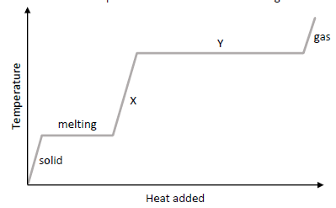
- Explain the shape of the graph at part X.
- Explain the shape of the graph at part Y.
- Describe how the energy could have been supplied to the water.
- Ice has a latent heat of 330000 J kg^{–1}. Calculate how much energy is required to change 0.2 kg of ice to water.
- Explain why a steam burn is more dangerous than a burn from boiling water.

The temperature of the water needs to be measured throughout this experiment.
It is measured using a thermometer.
A thermometer uses a particular thermometric property to measure temperature.
- What is meant by a thermometric property?
- State two examples of thermometric properties.
- Describe, with the aid of labelled diagram, a laboratory experiment to calibrate a thermometer.

2012 Question 9 (b) [Ordinary Level]
20 g of ice cubes at 0 °C are added to a glass of warm water.
All the ice melts quickly and cools the water to 5 °C.
Assuming no heat transfer to the surroundings or to the glass,
- Calculate the energy required to melt the ice.
- Calculate the energy required to warm the melted ice to 5 °C.
- Why is it important to stir the mixture?
(specific heat capacity of water = 4180 J kg⁻¹ K⁻¹ ;
specific latent heat of fusion of ice = 3.34 × 10⁵ J kg⁻¹)

2016 Question 9 [Ordinary Level]
- What is meant by latent heat?
- Name an instrument used to measure temperature.

A glass bottle is filled with 0.75 kg of water at a temperature of 20 ⁰C.
The bottle is then placed in a freezer, which freezes the water and cools it to −15 ⁰C.
- Calculate the energy removed from the water to reduce its temperature to 0 ⁰C.
- Calculate the energy removed from the water to convert the water at 0 ⁰C to ice at 0 ⁰C.
- Calculate the energy removed from the water to cool the ice at 0 ⁰C to ice at −15 ⁰C.

Specific heat capacity of water = 4200 J kg^{–1} K^{–1}
Specific latent heat of fusion of water = 3.3 x10⁵ J kg^{–1}
Specific heat capacity of ice = 2200 J kg^{–1} K^{–1}

- The power rating of the freezer is 300 W.
How long will it take for the freezer to remove 9000 J of energy from the water?
- As the water freezes, the glass bottle cracks and shatters. Explain why this occurs.
- The freezer is an example of a heat pump. Outline the operation of a heat pump.

Heat: Higher level questions including specific heat capacity and latent heat

2004 Question 7 [Higher Level]
- Define specific heat capacity.
- Define specific latent heat.
- 500 g of water at a temperature of 15 ⁰C is placed in a freezer.
The freezer has a power rating of 100 W and is 80% efficient.
Calculate the energy required to convert the water into ice at a temperature of –20 ºC.
- How much energy is removed every second from the air in the freezer?
- How long will it take the water to reach a temperature of –20 ºC?
- Allowing a liquid to evaporate in a closed pipe inside the freezer cools the air in the freezer. The vapour is then pumped through the pipe to the outside of the freezer, where it condenses again.
Explain how this process cools the air in the freezer.
- The freezer causes the room temperature to rise. Explain why.
specific heat capacity of ice = 2100 J kg^{–1} K^{–1};
specific heat capacity of water = 4200 J kg^{–1} K^{–1};
specific latent heat of fusion of ice = 3.3 × 10⁵ J kg^{–1}

2016 Question 7 [Higher Level]
At a lecture in Cork in 1843, James Joule, while describing his work on heat and temperature, suggested the principle of conservation of energy. Later in the nineteenth century, the work of Joule and Lord Kelvin led to the invention of the heat pump.
- Distinguish between heat and temperature.
- State the principle of conservation of energy.

- As part of his presentation, Joule proposed that the temperature of the water at the bottom of the
Niagara Falls would be 0.12 °C greater than that at the top, due to gravitational potential energy being converted into heat energy.
Calculate the height of the Niagara Falls.

- In reality the increase in temperature will be much smaller.
Suggest a reason for this.

- In a heat pump, a fluid is used to transfer energy from a cold body to a warmer body.
Describe the operation of a heat pump and explain how a heat pump can be used to reduce the temperature of a cold region, for example the interior of a refrigerator.
- State two desirable physical properties of the fluid used in a heat pump.

The fluid in the heat pump of a refrigerator has a specific latent heat of vaporisation of 4.6 MJ kg^{–1}.
The internal volume of the refrigerator is 0.6 m³.
The heat pump removes 12 kJ of energy from the air in the refrigerator as the fluid evaporates.
- Calculate the mass of fluid that has evaporated
- Calculate the fall in temperature of the air in the refrigerator.

(specific heat capacity of water = 4200 J kg^{–1} K^{–1}; acceleration due to gravity = 9.8 m s^{–2};
density of air = 1.23 kg m^{–3}; specific heat capacity of air = 1005 J kg^{–1} K^{–1})

2020 Question 12 (b) [Higher level]
On a particular day, solar radiation falls on the surface of Antarctica at a rate of 850 W m^{–2}.
52% of the incoming radiation is infra‐red radiation.
The average frequency of the infra‐red radiation is 15 THz.
- Radiation is one of three methods of heat transfer. What are the other two methods?
- Calculate the infra‐red energy that falls on 0.25 m² of Antarctica in 3 minutes.
- Calculate the number of infra‐red photons that fall on this area in this time. {this part can only be answered after covering The electron chapter}

- As part of the greenhouse effect infra‐red radiation is reflected back to Earth. This leads to global warming. As the Earth warms its glaciers continue to melt. At present the total volume of ice in glaciers on Earth is 170,000 km³.
Calculate the energy required to melt 0.5% of the Earth’s glaciers if their average temperature is –6 °C and the melting point of glacier ice is –2 °C.

density of glacier ice = 920 kg m^{–3}
specific latent heat of fusion of glacier ice = 3.3 × 10⁵ J kg^{–1}
specific heat capacity of glacier ice = 2900 J kg^{–1} K^{–1}

2012 Question 12 (c) [Higher Level]
The graph shows the variation in temperature θ of 150 g of crushed ice when it was supplied with energy ΔE at a constant rate.

- Explain the shape of the graph.
- Describe how energy could have been supplied at a constant rate.
- Using the graph, estimate the specific latent heat of fusion of ice.

2021 Question 9 [Higher Level]
Ice is used as a coolant due to the high specific heat capacities of ice and water and the high specific latent heat of fusion of ice.
It is the principal coolant used in ice packs for insulated picnic boxes, such as the one shown.
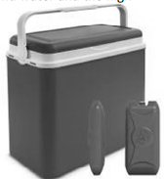
- What is meant by specific heat capacity?
- Why does the high specific latent heat of fusion of ice make it a good coolant?
- Suggest two reasons why the walls of a picnic box are made from hollow plastic rather than solid plastic.

A picnic box contains food items with an initial temperature of 10.5 °C.
The heat capacity of the food is 17.8 kJ K^{–1}.
An ice pack that contains 250 g of ice was taken from a freezer held at a temperature of – 18 °C and placed in the picnic box.
As the temperature of the ice increases and it melts, the temperature of the food decreases.

- Calculate the final temperature inside the picnic box when its contents have reached thermal equilibrium.
Freezers and refrigerators operate by use of a heat pump.
- Draw a labelled diagram of a heat pump.
- Explain how a heat pump works.

A student used the apparatus shown to investigate
how heat travels through water.
- What observations did the student make?
- What conclusion could the student have made?

specific heat capacity of ice = 2100 J kg^{–1} K^{–1};
specific heat capacity of water = 4180 J kg^{–1} K^{–1}
specific latent heat of fusion of ice = 3.3 × 10⁵ J kg^{–1}

{The next two questions are quite challenging and are perhaps best left as final revision questions}

2014 Question 12 (c) [Higher Level]
- Define specific latent heat.
- A drinking glass contains 500 g of water at a temperature of 24 °C.
Three cubes of ice, of side 2.5 cm, are removed from a freezer and placed in the water.
The temperature of the ice is –20 °C.
Calculate the mass of the ice.
- Calculate the minimum temperature of the water when the ice has melted.
density of ice = 0.92 g cm^{–3}
specific heat capacity of water = 4200 J kg^{–1} K^{–1}
specific heat capacity of ice = 2100 J kg^{–1} K^{–1}
specific latent heat of fusion of ice = 3.3 × 10⁵ J kg^{–1}

2011 Question 7 (a) [Higher Level]
- When making a hot drink, steam at 100 °C is added to 160 g of milk at 20 °C.
If the final temperature of the drink is to be 70 °C, what mass of steam should be added?
You may ignore energy losses to the surroundings.
- A metal spoon, with an initial temperature of 20 °C, is then placed in the hot drink, causing the temperature of the hot drink to drop to 68 °C.
What is the heat capacity of the spoon? You may ignore other possible heat transfers.

(c_{milk} = 3.90 × 10³ J kg^{–1} K^{–1}, c_{water} = 4.18 × 10³ J kg^{–1} K^{–1}, c_{hot drink} = 4.05 × 10³ J kg^{–1} K^{–1}
specific latent heat of vaporisation of water = 2.34 × 10⁶ J kg^{–1})

SOLUTIONS TO ORDINARY LEVEL MATHS QUESTIONS 2002 - 2022
2002 Question 12 (b)
- Q = mcΔθ Q = 1.5 × 4180 × 85 = 532 950 J.
- P=W/t P = 532 950/240 P = 2221 W.

2006 Question 7
- Q = mcΔθ ⇒ Q = (80)(1500)(285) = 34 200 000 J = 4.2 MJ
- P = W/ t ⇒ P = 34 200 000 / (10×60×60) = 950 W

2008 Question 7
- 100 – 20 = 80 °C
- Q = m cΔθ = 0.5 × 4200 × 80 = 168 000 J
- 2 kW = 2,000 W = 2,000 J per second.
- P = W/t so t = W/P t = 168 000/2,000 = 84 secs.

2012 Question 9
- t = T - 273(.15)
- E = ml = (20 ×10⁻³)(3.34 ×10⁵) = 6.68 ×10³ J
- E = mcΔθ = (20×10⁻³)(4.18 ×10³)(5) = ) 418 J

2013 Question 9
- E = mcΔθ = (1.3)(4200)(80-10) = 3.8 ×10⁵ J
- P = Energy/time = 3.8 ×10⁵ / 180 = 2123.3 W

2015 Question 9
- E = mcΔθ = (5×4180×80) = 167 200 J
- The energy is supplied by the kettle which has a power rating of 0.8 kW = 800 Watts which corresponds to 800 Joules per second.
- 167 200 Joules are required to heat the water, and energy is supplied at a rate of 800 Joules per second
So time taken is 167200/800
= 209 s

2016 Question 9
- Q = mcΔθ = 0.75 × 4200 × 20 = 63000 J
- Q = ml = 0.75 × (3.3 × 10⁵) = 247500 J
- Q = mcΔθ = 0.75 × 2200 × 15 = 24750 J
- $P=\frac{Work}{time}$ $time=\frac{Work}{power}$ $time=\frac{9000}{300}$ time = 30 s

2017 Question 12 (b)
- E = mcΔθ = 2 × 4200 × 25 = 210 000 J
- $$power=\frac{W}{t}= \frac{210000}{840}=250 W$$
2018 Question 12 (c)
- Q = mcΔθ = (0.7)(4200) (90-20) = 205800 J
- 3000
- Porer = Work/time so t = Work/Power t = 205800/3000 = 68.6 secs.
- At the bottom, because cold water is more dense and will sink down

2019 Question 8
- E = m c Δθ = (1.5)(4200)(88‐15) = 4.599 × 10⁵ J

2022 Question 8 [Ordinary Level]
330000 × 0.2 = 66000 J

"Ludwig Boltzmann, who spent much of his life studying statistical mechanics, died in 1906, by his own hand. Paul Ehrenfest, carrying on the work, died similarly in 1933. Now it is our turn to study statistical mechanics. Perhaps it will be wise to approach the subject cautiously." Introduction to States of Matter, David L. Goodstein
So why can’t we say that “the temperature of an object is a measure of how hot or cold an object is”? ‘Hot’ is a vague term. Does it refer specifically to temperature, or to the amount of heat in the object? After all, a litre of water at 100 ⁰C has twice as much heat as half a litre of water at 100 ⁰C but both are at the same temperature. ‘Hotness’ is the physicists’ way of overcoming this potential confusion. Temperature is a measure of the average kinetic energy of the atoms or molecules in the substance; the colder the temperature the more sluggish the molecules move. This is why objects expand as their temperature increases (the Eiffel Tower is 15 cm taller during the summer).
So if the temperature of an object increases by 10 ⁰C it will also increase by 10 K. This is not the case if you compare the Celsius (or kelvin) scale with the Fahrenheit scale.
SI stands for ‘Standard Internationale’ (French). Basically, it’s a system of units (incorporating the metric system) which connects up all the main physical quantities, and which has been agreed by all scientists (but not engineers, funnily enough). For more info on this see http://www.npl.co.uk/reference/. By the way, did you notice that we talk about degrees celsius but not degrees kelvin? I think it’s because for the celsius scale one degree corresponds to one hundredth of the temperature difference between freezing point and boiling point of water (similarly you can divide a circle up into 360 degrees) but the kelvin temperature scale is not defined in this way; it just has a baseline and then increases - hence no degrees.
The temperature of outer space is 2.7 K. This fact (found accidentally by a couple of scientists working for IBM in the 60’s) is one of the major pieces of evidence for The Big Bang. The coldest temperature ever reached anywhere in the universe occurred in 2003 when researchers in MIT managed to cool an object down to 0.00000000045 kelvin. It’s a common misconception to think that all motion would cease at 0 K. In practice thermodynamics tells us that we can never reach absolute zero. I will not be taking any further questions. Did you hear about the scientist who was accidentally cooled to absolute zero? He’s 0 K now.
How a thermocouple works When two dissimilar metals touch, electrons flow from one to the other, because the arrangement of electrons within the two metals are different and therefore a potential difference arises. Electrons then flow across this potential difference. You may have noticed this if you ever bit into tinfoil from a chocolate bar by mistake. When the two dissimilar metals have been in contact for a short period there is no longer a potential difference and no electrons flow. Heating up one end of the thermocouple changes the distribution of electron energies and between one end of the thermocouple and the other, causing a potential difference, this time between one end of the thermocouple and the other. As long as the temperature difference is maintained this EMF still exists. I think. Whelan and Hodgson (1989) Essential Principles of Physics (2nd Ed.), p391. Alternatively google the seebeck effect and/or the peltier effect.
Some may come close, but none are perfect. A useful classroom demonstration is to take the temperature of a beaker of water with different thermometers to show that they do actually give different readings. Imagine if different types of ruler gave different values for length? For what it’s worth, scientists use what is called the ‘constant volume-gas thermometer’ as the standard because it comes closer than any other thermometer to that elusive proportional relationship. It’s a bit too bulky and cumbersome for school purposes however. And why use mercury if mercury is toxic? Presumably because it comes reasonably close to expanding proportionally.
The thermocouple is more likely to be used in industry because it’s more accurate. It also has a wider temperature range (and it’s not as fragile).
Did you know that Ireland was once on two separate continents (known as Laurentia and Gondwana)? Hundreds of millions of years ago these continents came together and created the country we know today. The movement of continents is brought about by convection See gsi.ie for a history of Ireland’s geography. I am constantly bemused when students tell me that they don’t like or can’t ‘do’ Physics but take Geography as an alternative, not realizing that the ‘Physical Geography’ section is all based on Physics. But that’s on us. So much of what we teach in school is ‘compartmentalised’ to the extent that we lose sight of how much of this knowledge is interconnected.
You get up for a pee in the middle of the night. On your way to the bathroom you pass over different floors composed of (i) ceramic tiles, (ii) timber and (iii) woollen carpet. Now all three floors are at the same temperature (room temperature), so why do they seem to be at different temperatures? You hop on your bike to go to school on a very cold morning. Why does the frame of the bike seem to be much colder than the saddle?
So why the letter ‘U’? Apparently it’s short for the term ‘Unit Heat Loss Rate’. Note that the greater the U-value the poorer an insulator it is. U-Values are therefore a measure of the conductivity of a substance, i.e. a structure that is a good insulator has a low U-Value.
In the diagram above we have a cube of aluminium and a cube of copper. Both have a mass of exactly 1 kg. We’re going to conduct a little thought experiment: - Imagine that all the heat from each bunsen burner is going directly to the metal above it (and that none will be lost to the environment. - Keep heating until they have both increased by one degree celsius (this would also be one kelvin). - In a simple world it would take the same amount of heat for both metals by 1 ⁰C (because they both have the same mass). But in our world each metal is made from a different material and therefore each will require a different amount of heat energy to increase the temperature by 1 ⁰C. In fact the aluminium requires 910 joules for this to happen while the copper requires 390 joules. - It doesn’t matter what temperature they are to begin with either, in each case it takes a specific amount of energy to increase the temperature of each one kg mass by one degree. - We refer to this specific amount of energy as the specific heat capacity of the substance. - Note also that if the kilogram of aluminium cooled down by one degree, it would lose (or give out) 910 joules of energy and the copper would lose 390 joules.
This is similar to how we explained the ‘U-value’.
Why ‘Q’? Best guess is that it represents ‘Quantity’ of heat.
This question had me snookered until I noticed the image of the kettle.
What is a calorie? One heat calorie (small c) is the amount of heat energy needed to raise the temperature of 1 gram of water by 1°C. However a food calorie is 1000 times larger than a heat calorie, so is technically called a Calorie, with a big “c”, to make the distinction. In other words, a Calorie is a kilocalorie, or kcal for short. To make things even more complicated, food labelling often uses kilojoules, so one Calorie equals 4180 joules. All clear as mud?
By now you will have (hopefully) noticed that it doesn’t matter if the object is being heated from 2⁰ C to 3⁰ C, or from 92⁰ C to 93⁰ C; each is an increase of 1⁰ C and therefore the same amount of heat energy is required in both cases. Basically, if a substance has a high s.h.c. a lot of heat is required to change its temperature regardless of it’s temperature If a certain amount of heat is needed to raise the temperature of an object by 1⁰ C (1 K), this same amount of heat will be given out if the object cools by 1⁰ C. Remember that a temperature difference of 1 K is the same as a temperature difference of 1⁰ C.
This concept is useful is if we want to look at how much energy it takes to heat all our oceans by 1 degree. So presumably the boffins have a rough estimate of the heat capacity of our oceans and given that we are looking at the very definite possibility of the extinction of the entire human race due to global warming in the next few decades, it seems that heat capacity is something we should all be aware of. So there’s that.
If you've got a block of ice at –5⁰ C and heat it up the melted water will not rise above 0⁰ C until all the ice has melted. The heat which is being added is not causing a rise in temperature – hence the term ‘latent’ (‘hidden heat’). Only when all the ice has turned to water does the temperature begin to rise again. Similarly when the water reaches boiling point at 100⁰ C, the water which turns to water vapour first will not rise above 100⁰ C until it's all water vapour. Nobody has ever asked me why this should be the case, which is a small cause for concern, but just goes to show that we really are teaching students not to think for themselves. Anyway, to make sense of the curve I presume it must mean that ice absorbs heats better than water which would explain why all the ice turns to water before the water heats up, and similarly at the water/steam point. Now this merely begs the follow up question; why does ice absorb heat more quickly than water? This in turn brings us back to our definitions of heat capacity. Why does one substance have a different specific heat capacity than another? I guess it must mean that the forces between the water molecules in the ice stage are less than the forces between them in the water stage. But isn't it interesting that we as physics teachers give the impression that what you read in the book is all there is to it, whereas in actual fact these questions only serve to open the door on a whole new and deeper level of understanding. It's no wonder that students are walking away from physics in the classroom. Or maybe it’s just me. Oh by the way, all (and I mean all) textbooks which give this diagram conveniently omit to mention that it is next to impossible to achieve this in practice.. It assumes all energy goes into the water; that there is no loss of energy by conduction, convection or radiation; that water evaporates only when it is boiling, and that pressure is kept constant.
Latent heat is the heat required to loosen or break down the bonds between molecules when materials change from being a solid to a liquid, or from a liquid to a gas. Alternatively it corresponds to the heat released when a liquid changes to a solid or a gas to a liquid. This, together with the graph above explains why a saucepan of water won’t immediately turn to water vapour upon boiling. It takes energy for this to happen and the energy is only being supplied slowly via the hob of the oven. Assuming you have one litre of water it will take 4180 J to heat it from 99 ⁰C to 100 ⁰C but 2230000 J to turn that amount of water into water vapour; you have add a huge amount of energy to turn water into water vapour. Here’s a tip for when global warming really kicks in. The best way to get to sleep on a really hot night is to soak a towel in cold water and wrap it around your feet. Can you explain why?
Did you know that if you leave a fridge open it will not cool down a room? This is because all the heat it removes merely gets transferred to the back of the fridge where it gets pushed out into the room.

